**The British College**

**Work-In Progress Documentation**





**Project Manager:**

Rohit Raj Pandey

**Team 7 (Nature’s Fresh Mart)**

Saugat Thapa

Gaurav Bhansali

Aakash Das

Harsh Kumar Gupta

Rajesh Basnet

**Table of Contents**

1. **Initiation Phase**
   1. **Project Charter**

* Version Control
* Project Justification
* Project Scope
* Project Assumption
* Rules & Responsibilities
  1. **Meeting Minutes**

1. **Planning Phase**
   1. **Belbin Analysis**

* Team Belbin’s Analysis
* Individual Belbin’s Analysis
  1. **Skills Audit**
* Team Skills Audit
* Individual Skills Audit
  1. **Project Management (MS Project)**
* Gantt Chart
* Network Diagram
* Timeline
* Calendar
* Resource Sheet
* Change Working Time
* Task Sheet
  1. **Communication Tool Used**
* Google Drive
* Discord

1. **Execution**
   1. **Entity Relationship Diagram**

* EERD
* ERD
* Final Composite
* Logical Table
  1. **Use Case Diagram**
* Overview Use Case Diagram
* Customer Use Case Diagram
* Trader Use Case Diagram
* Admin Use Case Diagram
  1. **Requirement Catalogue**
* Functional Requirement
* Non-Functional Requirement
  1. **Logo Design**
  2. **Wireframe**
  3. **Product Development**
* Website Homepage
* Product page
* Sign In

1. **Initiation Phase**
   1. **Project Charter**

|  |
| --- |
| Project Title: Nature’s Fresh Mart  Project Manager: Rohit Raj Pandey  Sponsor: The British College  Customer: Locals of Cleckhuddersfax |

Version Control

|  |  |  |
| --- | --- | --- |
| Version | Date | Summary of changes |
| 1 | 02/05/2021 | Initial Project Plan |
|  |  |  |

Project Justification

|  |
| --- |
| A group of small independently owned local businesses located at a popular suburb of Cleckhuddersfax have decided to band together and create an e-commerce platform in response to national chains setting up convenience stores in their area. This platform helps the traders sell their fresh goods without having to compete with the opening hours without losing out on family life.  Locals who could not shop during normal opening hours can now buy locally sourced fresh high quality foods which are usually unavailable in larger supermarkets but the demand for such products are increasing. In this way, initially, the traders hope to increase their revenue, recognition and reach a larger market.  The local business owners of the suburbs of Cleckhuddersfax came to a conclusion that in order to counter the national chains opening convenience stores in their local areas they would have to shift their operations online, more specifically an e-commerce site which will host their products. The online e-commerce store is going to hold products of only five vendors as an initial pilot project but can support up to ten vendors and each one of them will have their specific product lines unique to them.  To compete with the opening hours of bigger convenience stores in the area without missing out on precious family time is the main reason why the traders are willing to invest in an e-commerce site. This also means that there is an opportunity for the traders to widen their markets out of their local suburbs to other areas which inturn increases their revenue and recognition as a trustworthy fresh food online marketplace. The site will also boasts a trader interface which allows the traders to manage their products and other relevant information by themselves. In order to maintain a secure environment ,the traders have their own login information that they will use to maintain their stock of goods and also other sensitive information such as reports, charts and the overall financial overview of the store. Traders can login to the database on a daily basis to look up on reports, on orders and stock levels and so on and also determine their future plans. From the dashboard, the traders can view their daily, weekly or monthly reports.  The thriving local shops in the area even in the presence of supermarkets within a few minutes drive tells us that the local people are more willing to buy goods produced locally from the small shops rather than drive to the supermarket. This also means that this e-commerce site is also going to make the lives of the local people, who are usually working during the opening hours of the shops,easier by enabling them to buy the locally produced fresh goods with a few clicks. Customers are saved from the hassle of actually going to the physical stores. The e-commerce site will boast a user interface that captures the local heritage of the particular area. The users will be able to sort products according to the shops or the type of product but the users first need to be registered in order to buy anything from the store so that they can be members of this e-commerce site. On top of being easy to navigate, the site can also be accessed in phones and tabs because of its responsive design. It is a super convenient way of doing your grocery shopping from the comfort of your home , however you(the customer) will have to order a day before in advance to receive your goods the following day, in addition the customers can choose time slots for when they would like their goods to be delivered to the nearest shop. Initially, you can only use PayPal to pay for your items but Stripe may also be used in the future as the traders have shown interest in it.  In a nutshell, the whole point of creating an online e-commerce site is to enable small independently owned local businesses a platform where they can aggregate and sell their products which is convenient for them and also the people buying their products. In a place where local shops are thriving even in the presence of supermarkets nearby indicates a demand for locally produced fresh goods and this platform provides the perfect way to bridge the gap between supply and demand which ends up making the lives of everyone involved much easier. |

Project Scope

|  |
| --- |
| **SMART Goals:**   1. To bring different product lines together for the ease of customers as well as traders. 2. To develop a decent e-commerce platform service for developing a relation between customers and traders. 3. This project targets both the customer’s satisfaction as well as trader’s benefit. 4. This project targets to increase the customer base by 60% till the end of second quarter. 5. User-friendly, easily accessible and a flexible website built prioritizing both traders and customer’s needs. 6. Availability of feedback and report regarding goods quality and product safety. 7. Initially, Transaction payments for orders should be done through PayPal by customers. 8. Since, Stripe is being suggested for exploring it might come in use ahead. 9. Working progress will be presented in the 6th week from the starting date. |
| **Customer Interface:**   1. Initially, the project includes 5 traders which might expand later based on the customer demands. 2. Navigation to products is done through shops or product type based on the user's requirement. 3. Resulting site will be responsive on popular browsers as well as mobile devices. 4. Availability of Cart feature to hold and manage orders and payment made by the customer. 5. Registration system for new users while login if already a member. 6. PayPal will initially be preferred as a payment scheme. 7. Users will be offered 3 collection slots for delivery i.e. Delivery slot selection.   **Trader Interface:**   1. Traders are flexible to add, delete, update, and manage products via web interface. (CRUD) 2. Regular order reports are produced for traders to review. (Must be logged in). 3. Accounts are secured and sensitive information is encapsulated to maintain privacy.   **Management Interface:**   1. Dashboard is available that includes daily and periodic reports to traders. 2. Weekly finance reports will be available on delivered goods. 3. Traders can access monthly report on product sales in different ways: alphabetically or by total number of orders per product or by total income per product |

Duration

|  |
| --- |
| Start Date: 2nd May 2021  Completion Date: 25th June 2021  Work in Progress: 7th June 2021  Final Presentation: 2nd July 2021  Team Portfolio: 12th July 2021 |

Estimated Budget

|  |
| --- |
| N/A  **Working Hours:**  Rajesh Basnet: Working Day: 5 : Working Hour (4 * 5 = 20 hr / week )  Saugat Thapa: Working Day: 5 : Woking Hour (4 * 5 = 20 hr / week )  Gaurav Bhansali: Working Day: 5 : Working Hour (4 * 5 = 20 hr / week )  Aakash Das: Working Day: 5 : Working Hour ( 3 * 5 = 15 hr / week )  Harsh Kumar Gupta: Working Day: 5 : Working Hour ( 4 * 5 = 20 hr / week ) |

Roles and Responsibilities

|  |  |
| --- | --- |
| Name | Role |
| Saugat Thapa | Primary Role (Co-Ordinator), Secondary Role ( Plant ), Least Likely Goal ( Shaper ) |
| Gaurav Bhansali | Primary Role (Shaper), Secondary Role (Team worker ), Least Likely Goal ( Plant ) |
| Aakash Das | Primary Role (Resource Investigator), Secondary Role (Team worker), Least Likely Goal ( Implementer ) |
| Harsh Kumar Gupta | Primary Role (Team worker), Secondary Role ( Monitor Evaluator ), Least Likely Goal ( Complete Finisher ) |
| Rajesh Basnet | Primary Role ( Specialist ), Secondary Role ( Complete Finisher ), Least Likely Goal ( Resource Investigator ) |

* 1. Meeting Minutes

Discord

3th May, 2021

04:00pm to 07:00pm

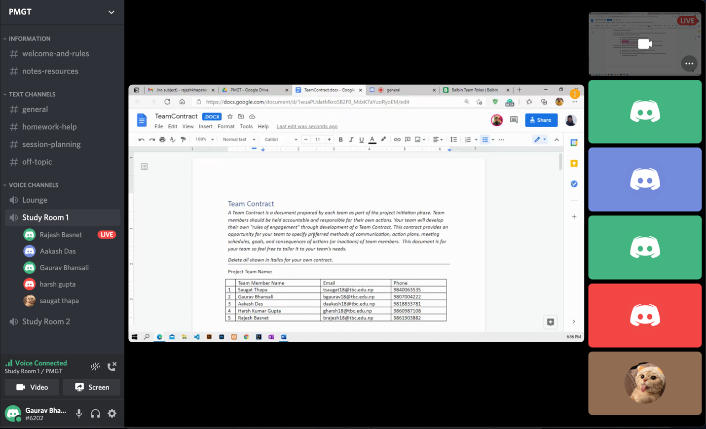

Work done:

Project charter completed.

Roles were distributed.

Team contract started.

On 4th may, 2021

2:00pm to 7:00pm

Work done:

Team contract almost completed.

On 5th May, 2021

3:00pm to 4:30pm

Work done:

Team Contract completed.

On 6th May, 2021

4:00pm to 7:00pm

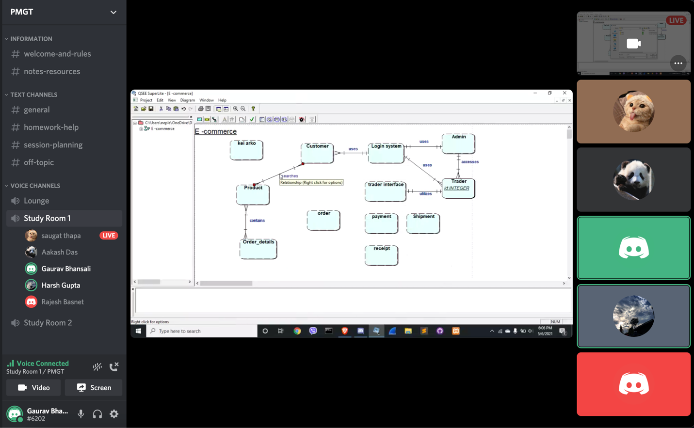

Work done:

ER Diagram started

On 7th May,2021

4:10pm to 6:50pm

Work done:

ER diagram completed.

EER diagram started.

On 9th May,2021

4:10pm to 6:20pm

Work done:

Skills Audit started.

EER diagram completed.

UseCase diagram started. (UML)

On 10th May,2021

4:00pm to 6:00pm

Work done:

UseCase Diagram completed. (UML)

On 11th May,2021

4:00pm to 6:35pm

Work done:

Skills Audit work-in progress.

On 12th May,2021

4:00pm to 6:00pm

Work done:

Skills Audit completed.

Wireframe discussion using Figma.

On 13th May, 2021

4:00pm to 5:30pm

Work done:

Selection of logo.

Wireframe discussion.

On 14th May, 2021

4:00pm to 5:00pm

Work done:

Wireframe discussion.

On 16th May, 2021

4:00pm to 6:30pm

Work done:

ER diagram modification.

EER diagram modification.

On 17th May,2021

3:00pm to 6:00pm

Work done:

ER diagram version 1 completed.

EER diagram version 1 completed.

Logical table version 1 completed.

On 18th May, 2021

4:00pm to 6:30pm

Work done:

Composite diagram completed

On 20th May, 2021

4:00pm to 5:00pm

Work done:

EER diagram discussion.

UI/UX discussion.

On 21st May,2021

4:00pm to 7:00pm

Work done:

EER diagram version 1 updated.

On 22nd May, 2021

1:00pm to 6:00pm

Work done:

ERD diagram finalized.

EER diagram finalized.

Logical diagram finalized.

EERD Composite finalized.

On 23rd May, 2021

4:00pm to 5:00pm

Work done:

Moqup started.

Logo design started.

On 24th May, 2021

4:00pm to 6:45pm

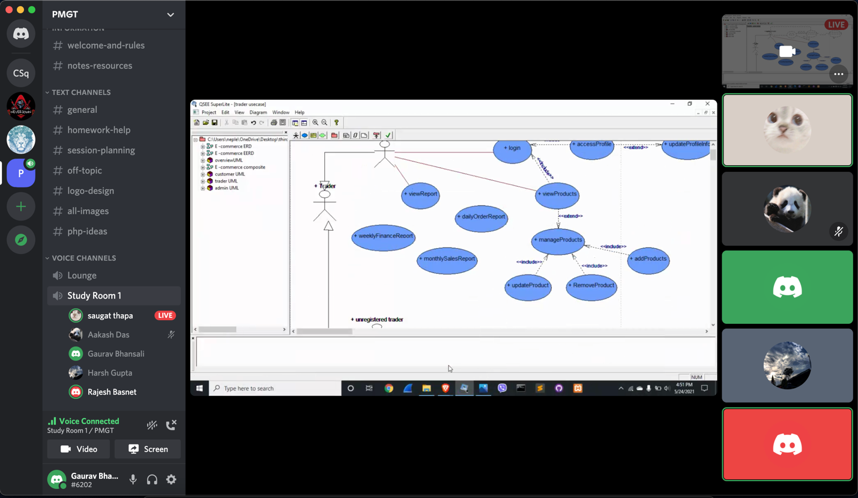

Work done:

Admin Use Case created.

Trader Use Case created.

Management Use Case created.

Wireframe work-in progress.

On 25th May,2021

4:00pm to 7:00pm

Work done:

Overall Use Case created.

On 26th May, 2021

4:00pm to 5:40pm

Work done:

Wireframe discussion.

Mockup discussion.

On 27th May, 2021

3:00pm to 5:15pm

Work done:

Wireframe discussion.

Mockup discussion.

On 28th May, 2021

4:00pm to 6:00pm

Work done:

Wireframe finalize.

Mockup finalize.

On 30th May, 2021

3:00pm to 7:00pm

Work done:

Production Development completed.

MoSCoW rule started.

On 31st May, 2021

4:00pm to 6:00pm

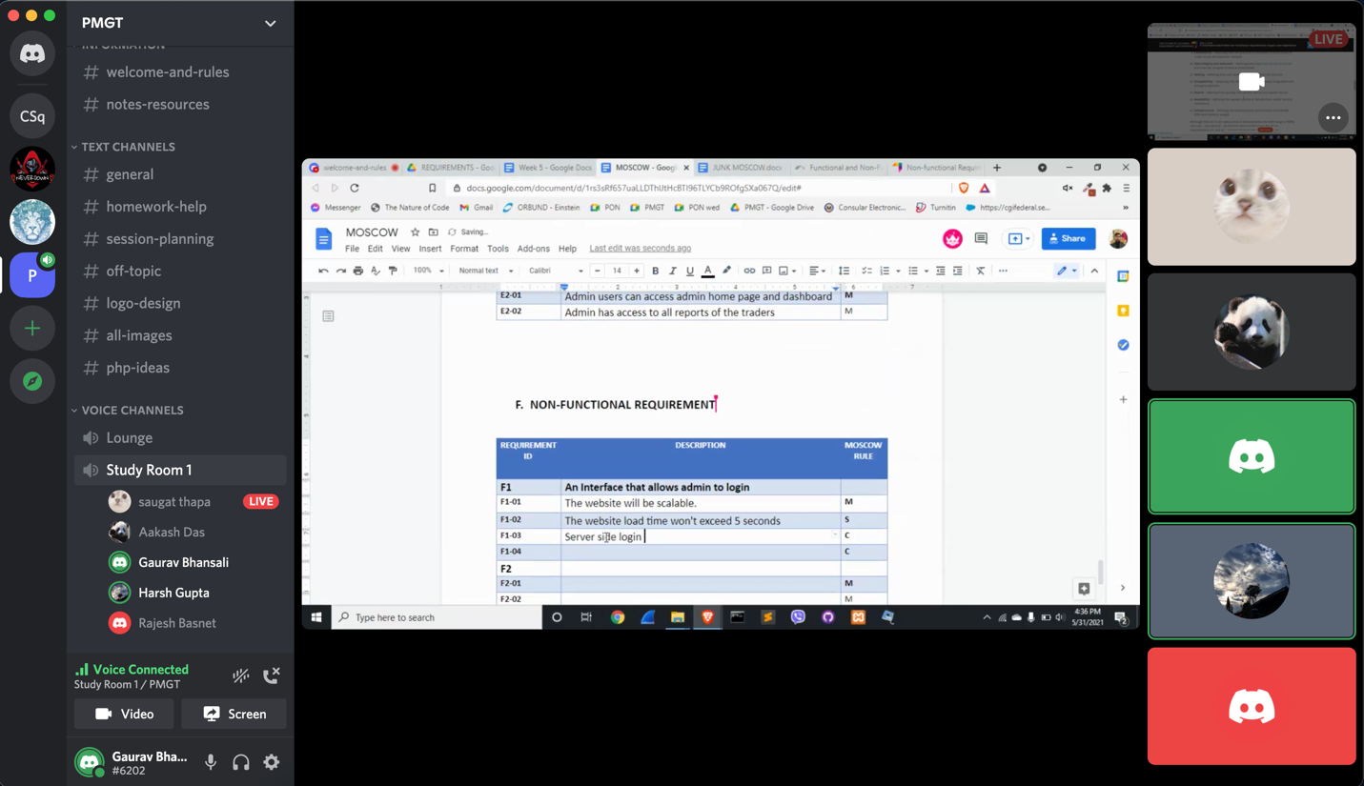

Work done:

MoSCoW rule work-in progress.

Risk Register started.

On 6th June,2021

4:00pm to 5:30pm

Work done:

MoSCoW rule completed.

On 7th June,2021

4:00pm to 4:45pm

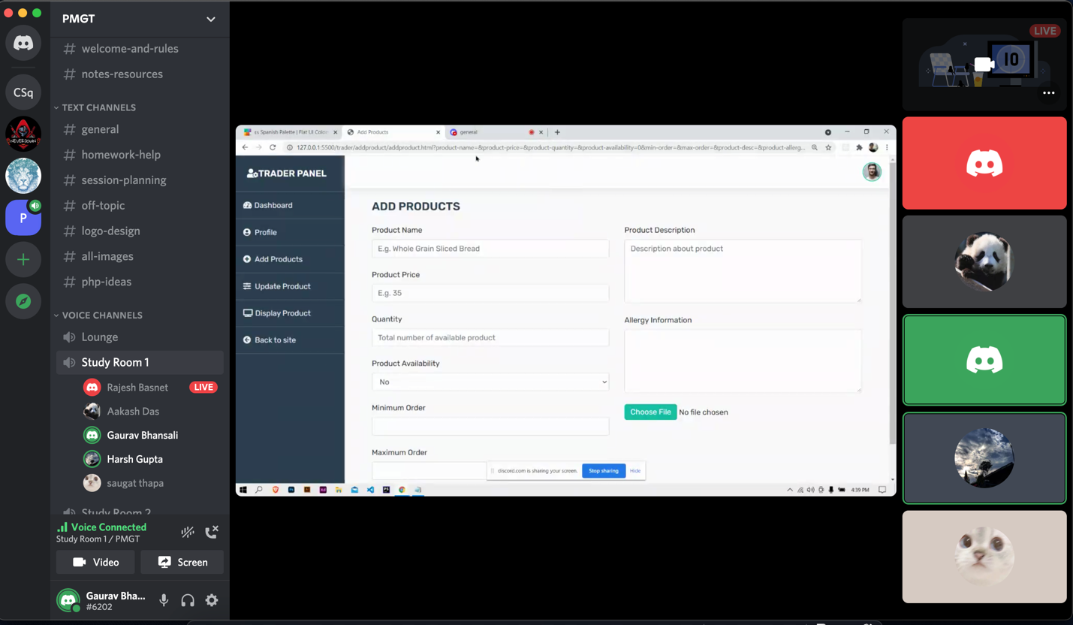

Work done:

Trader panel work started.

Work-in progress documentation started.

**2. Planning Phase**

2.1 Belbin’s Analysis

Team Belbin’s Analysis

|  |  |  |
| --- | --- | --- |
| Version:1.0 **Belbin’s Analysis** Date reviewed: | | |
| Primary role | Saugat | Co-Ordinator |
| Gaurav | Shaper |
| Aakash | Resource Investigator |
| Harsh | Team Worker |
| Rajesh | Specialist |
| Secondary role | Saugat | Plant |
| Gaurav | Team Worker |
| Aakash | Team Worker |
| Harsh | Monitor Evaluator |
| Rajesh | Complete Finisher |
| Least likely role | Saugat | Shaper |
| Gaurav | Plant |
| Aakash | Implementer |
| Harsh | Complete Finisher |
| Rajesh | Resource Investigator |

Individual Belbin’s Analysis

|  |  |  |
| --- | --- | --- |
| Version:1.0 **Belbin’s Analysis** Date reviewed: | | |
| Primary role | Harsh Gupta | Team Worker |
| Secondary role | Harsh Gupta | Monitor Evaluator |
| Least likely role | Harsh Gupta | Complete Finisher |

2.2 Skills Audit

Team Skills Audit

|  |  |  |  |  |  |  |  |  |
| --- | --- | --- | --- | --- | --- | --- | --- | --- |
| NO# | Skill Required | Skill Level ( 1- 5) | Training Action | Training Objective | Time (hrs) | Training Completion Deadline | Training for? |  |
| 1 | HTML | 3.7 | Revise HTML from W3Schools and learn new HTML5 templates. | Become better in creating basic structure of webpages | 21 | 04/06/2021 | Harsh, Gaurav, Saugat |  |
| 2 | CSS | 3.3 | Follow w3schools, tutorials point and YouTube. | Refresh my knowledge on basic css tags and make the pages attractive. | 28 | 04/06/2021 | Gaurav , Harsh, Saugat |  |
| 3 | JavaScript | 2.2 | Revise ES6 and learn from notes as well as MDN. | To make website user friendly by making cart buttons, number of goods left/payment method | 49 | 06/06/2021 | Harsh, rajesh , saugat |  |
| 4 | Bootstrap | 2.7 | Follow official Bootstrap document and also take a guide from YouTube. | To make web pages more stylish and responsive. | 37 | 08/06/2021 | gaurav, harsh , saugat |  |
| 5 | jQuery Plugins | 2.1 | Follow YouTube tutorials and follow websites like w3schools, tutorials point, etc. | To be able to use the jQuery library to write better javascript easily | 26 | 06/06/2021 | gaurav, harsh , saugat |  |
| 6 | PHP | 3 | Revise and learn all the syntax from W3Schools. | Become more confident in handling backend and database | 46 | 6/18/2021 | harsh, rajesh ,saugat |  |
| 7 | MySQL | 3.1 | Review from different websites and YouTube videos | To use database more efficiently and learn different syntax. | 21 | 15/06/2021 | harsh, gaurav, rajesh, saugat |  |
| 8 | Apache | 2.6 | Revise previous module course and go through YouTube, google for further study | To run web pages and PHP in host environment. | 13 | 16/05/2021 | gaurav, harsh , saugat |  |
| 9 | Photoshop | 2.8 | Look for solutions to specific parts we may need during the duration of the project on YouTube and google and be able to perform those actions efficiently | To re-create or edit images of different MIME types for implementations in websites. | 28 | 05/06/2021 | aakash, harsh, rajesh |  |
| 10 | Illustrator | 2.5 | Watch videos on youtube related to objects creation and different features. | To make innovative images and for different objects. | 31 | 6/10/2021 | aakash, harsh, rajesh |  |
| 11 | Mock flow | 2.5 | Play around in the mock flow environment and ask for help with teammates if needed. | To be able to prototype wireframe and produce a skeleton of the website to be created | 22 | 6/5/2021 | gaurav, harsh , aakash |  |
| 12 | Figma | 2.4 | Watch videos related to UI/UX design on YouTube which uses Figma | To create prototype for building websites. | 24 | 6/2/2021 | gaurav, harsh , rajesh |  |
| 13 | Qsee | 3.1 | Revise previous module course and go through YouTube, google for further study | To be confident in drawing erd eerd, use-case models, network model | 20 | 5/20/2021 | gaurav, harsh , Rajesh, Saugat |  |
| 14 | API | 1.5 | Learn and explore different API from YouTube as well as Google. | To interact with external software components and microservices. | 46 | 6/21/2021 | harsh, Rajesh , saugat |  |
| 15 | Sandbox | 1 | Follow the related videos of the sandbox and take a guide from YouTube or Google. | To implement payment scheme for the use of PayPal using Sandbox | 57 | 6/22/2021 | harsh, Gaurav, Rajesh, aakash |  |
| 16 | MS-Project | 1.1 | Follow YouTube tutorials and google, lastly instruction from tutor | To handle projects, maintain schedule, assigning resources to tasks and managing workloads. | 39 | 5/24/2021 | gaurav, rajesh, saugat |  |
| 17 | MS-Word | 4.3 | Use it daily taking help from YouTube if needed | To be able to easily document meeting notes, produce reports etc professionally | 8 | 5/11/2021 | aakash, harsh, saugat |  |
| 18 | MS-Excel | 3.9 | Play around in excel and look for solutions of specific problems we may encounter on YouTube or google | To be able to maintain tables , create columns with specific data types , use formulas on different columns, etc | 10 | 5/12/2021 | Aakash, harsh, Rajesh |  |
| 19 | Discord | 3.9 | Follow YouTube tutorials to learn to create things like bots, chat rooms and voice channels | To be able to conduct regular meetings regarding project management | 12 | 5/11/2021 | Gaurav, harsh, saugat |  |

Individual Skills Audit

|  |  |  |  |  |  |  |  |
| --- | --- | --- | --- | --- | --- | --- | --- |
| Skills Audit (Individual) | | | | | | | |
|  |
|  |  |  |  |  |  | Skill Level: 1 (No Knowledge) - 5 (Competent) | |  |
|  | Date Reviewed: 5/11/2021 | | Completed By: Harsh Kumar Gupta | Version :1.0 |  |  |
|  |  |  |  |  |  |  |
| NO# | Skill Required | Skill Level (1- 5) | Training Action | Training Objective | Time (hrs.) | Training Completion Deadline | Training for? |  |
| 1 | HTML | 3.5 | Follow w3schools lastly YouTube also learn latest changes | To be able to design backbone for website | 6 | 6/2/2021 | Harsh Kumar Gupta |  |
| 2 | CSS | 3 | Follow w3schools lastly YouTube | To give more styling to the website | 9 | 6/4/2021 | Harsh Kumar Gupta |  |
| 3 | JavaScript | 1.5 | Follow w3schools, MDN lastly YouTube | To make website user friendly by making cart buttons, number of goods left/payment method | 10 | 6/6/2021 | Harsh Kumar Gupta |  |
| 4 | Bootstrap | 2 | Follow w3schools lastly YouTube | To be able to develop frontend of site more easily with its predefined classes | 15 | 6/8/2021 | Harsh Kumar Gupta |  |
| 5 | jQuery Plugins | 1.5 | Follow w3schools, YouTube | To add functional feature which is difficult to use with the help of JavaScript | 10 | 6/6/2021 | Harsh Kumar Gupta |  |
| 6 | PHP | 2.5 | Follow w3schools, geeksforgeeks lastly YouTube | To be more use to PHP code and handle the backend processes including database | 15 | 6/18/2021 | Harsh Kumar Gupta |  |
| 7 | MySQL | 2.5 | Revise previous module course and go through YouTube, google for further study | To be able to keep record of data appropriately on the back end | 10 | 6/15/2021 | Harsh Kumar Gupta |  |
| 8 | Apache | 2.5 | Revise previous module course and go through YouTube, google for further study | To be able to run website on local server | 5 | 5/14/2021 | Harsh Kumar Gupta |  |
| 9 | Photoshop | 2.5 | Follow YouTube tutorials and google and previous module course as well | To be confident in making logo and edit other pictures required in website | 6 | 5/18/2021 | Harsh Kumar Gupta |  |
| 10 | Illustrator | 2 | Follow YouTube tutorials and google and look up to previous module slides | To be confident in making logo and graphs, illustration | 7 | 5/21/2021 | Harsh Kumar Gupta |  |
| 11 | Mock flow | 2.5 | Follow YouTube tutorials and google out any query | Become more confident in designing wireframes for website | 8 | 5/27/2021 | Harsh Kumar Gupta |  |
| 12 | Figma | 2 | Follow YouTube tutorials and google | To be confident in UI/UX design for making prototyping | 8 | 5/30/2021 | Harsh Kumar Gupta |  |
| 13 | Qsee | 2.5 | Revise previous module course and go through YouTube, google for further study | To be confident in drawing erd, eerd,use-case models, network model | 7 | 5/17/2021 | Harsh Kumar Gupta |  |
| 14 | API | 1.5 | Follow YouTube tutorials and google and learn | To interact with external software components, operating systems | 12 | 6/19/2021 | Harsh Kumar Gupta |  |
| 15 | Sandbox | 1 | Follow YouTube tutorials and google | To be able to make a payment system like PayPal | 10 | 6/20/2021 | Harsh Kumar Gupta |  |
| 16 | MS-Project | 1.5 | Follow YouTube tutorials and take google lastly instruction from tutor | To be able to manage project deadlines/documents | 6 | 5/23/2021 | Harsh Kumar Gupta |  |
| 17 | MS-Word | 4 | Use it daily taking help from YouTube | To be able to fill documents like project charter, team contract and so on | 2 | 5/11/2021 | Harsh Kumar Gupta |  |
| 18 | MS-Excel | 3 | Use it daily taking help from YouTube | To be able to keep record of data like attendance, skills audit, risk factors etc. | 4 | 5/12/2021 | Harsh Kumar Gupta |  |
| 19 | Discord | 3.5 | Learn it by using it on daily basis and YouTube | To be able to conduct regular meetings regarding project management | 2 | 5/11/2021 | Harsh Kumar Gupta |  |

2.3 Project Management

Gantt Chart

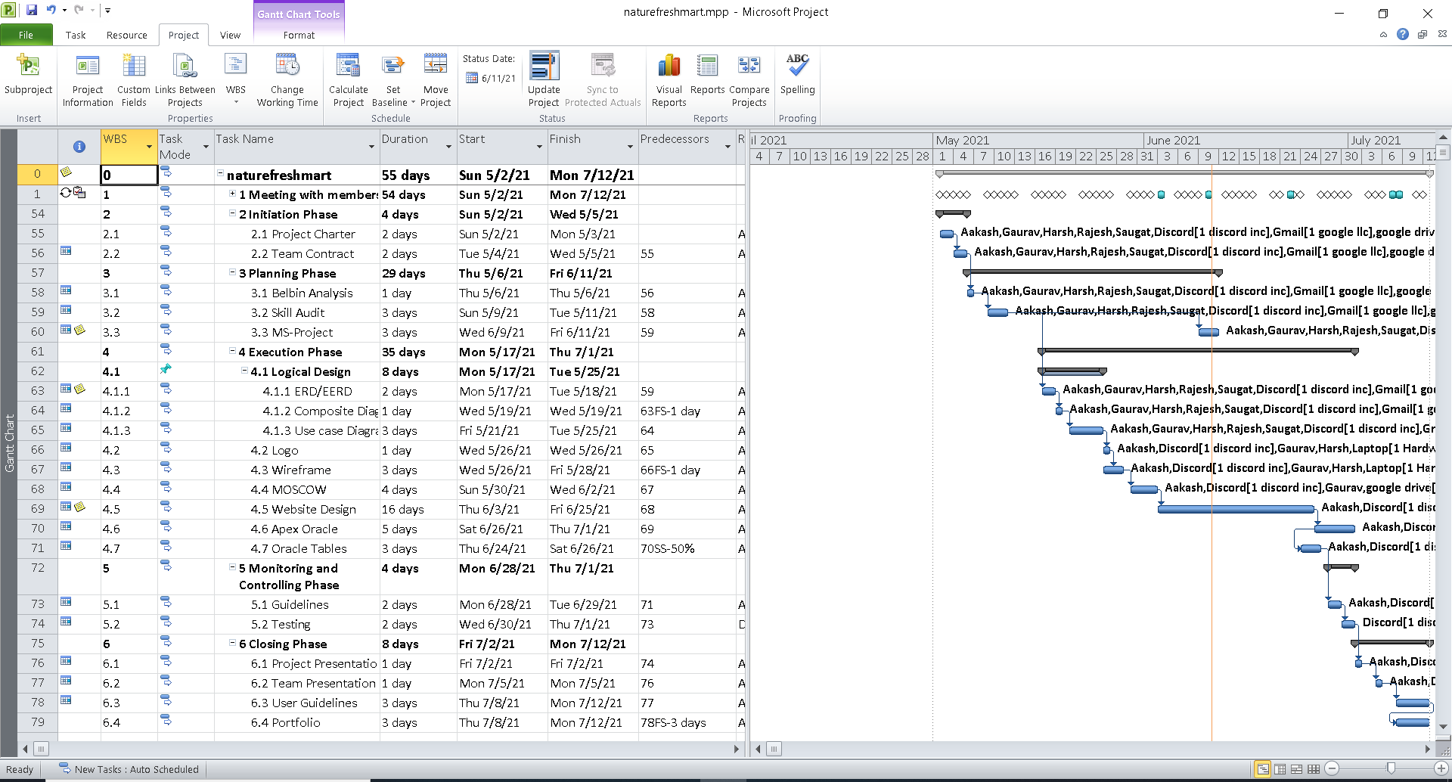

Network Diagram

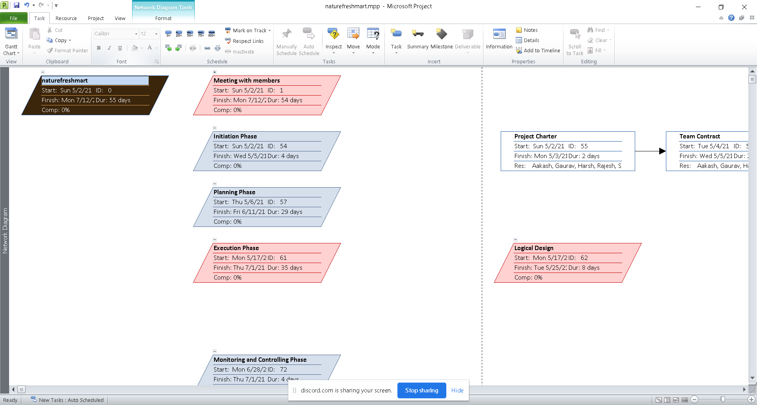

Timeline

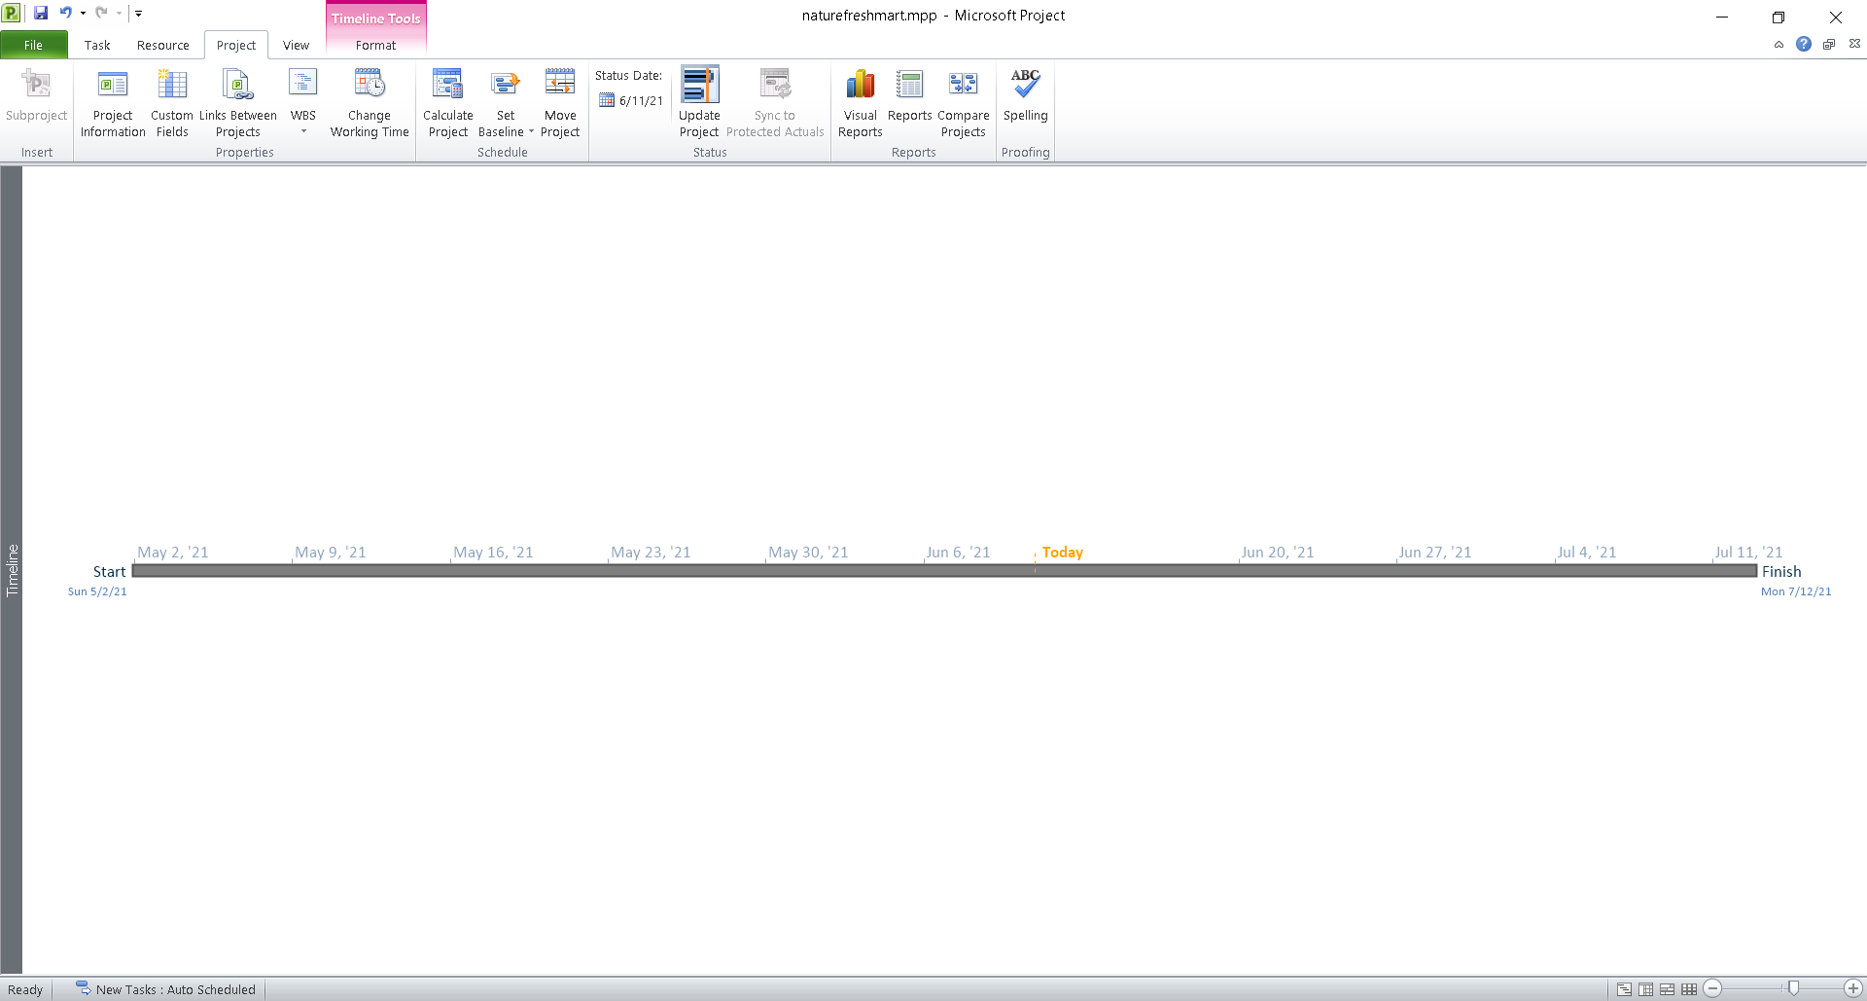

Calendar

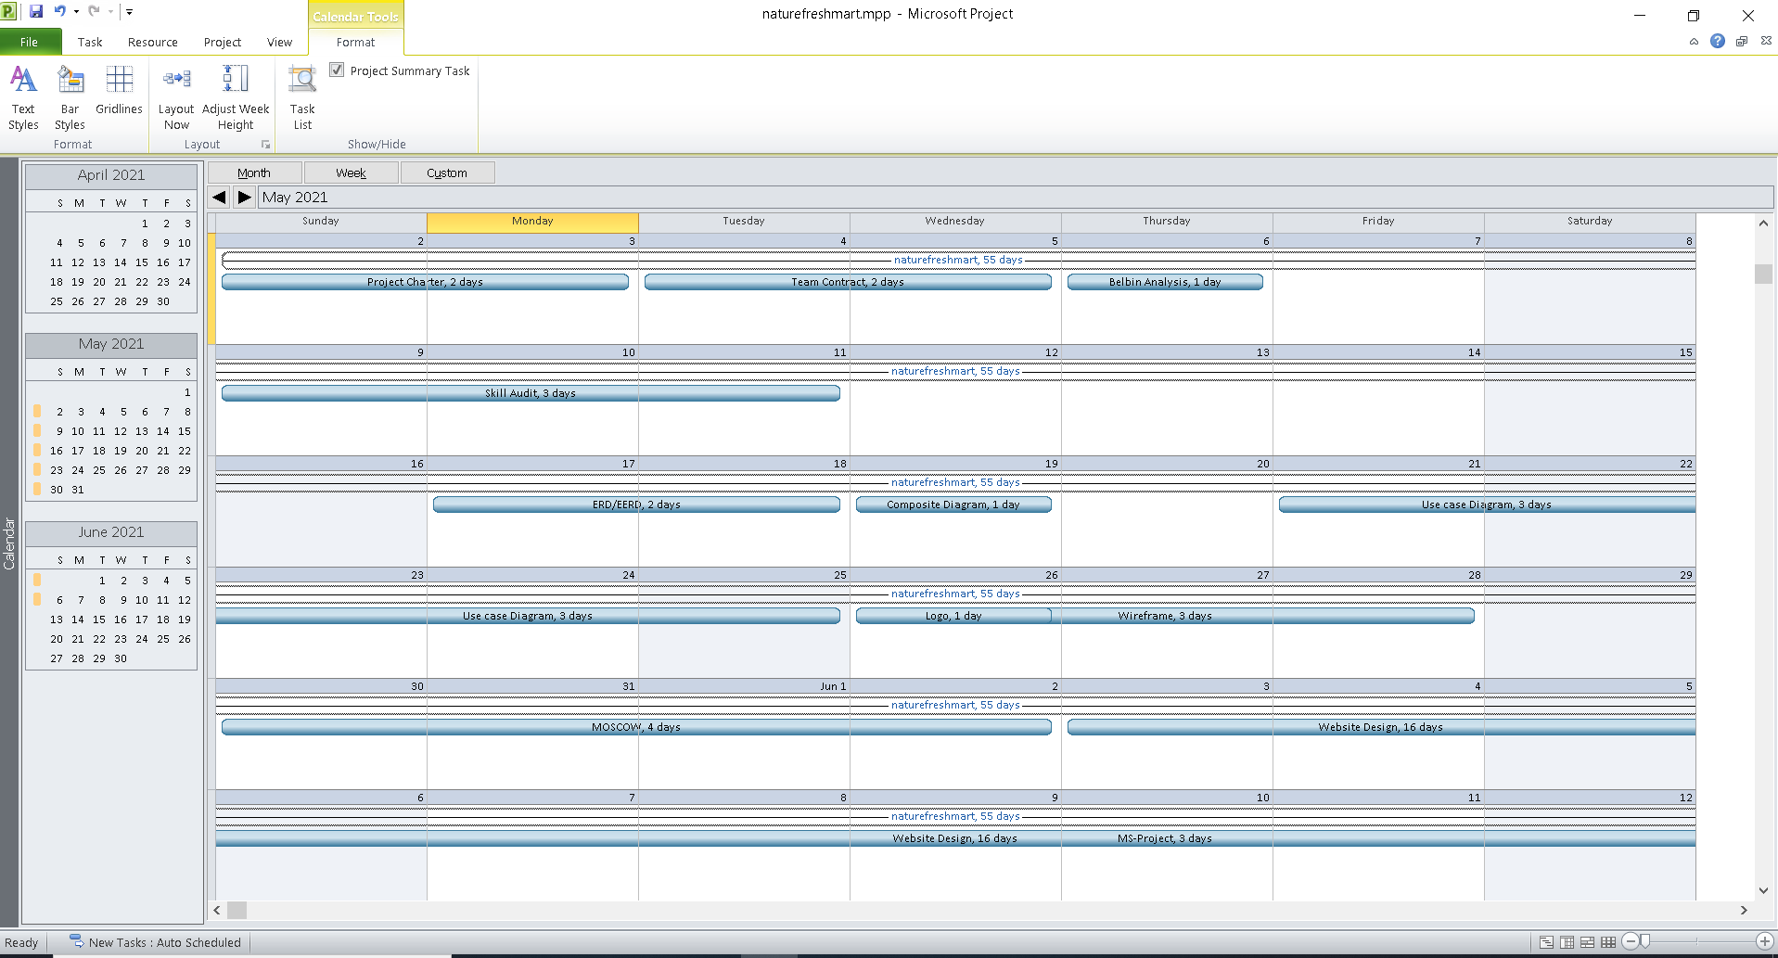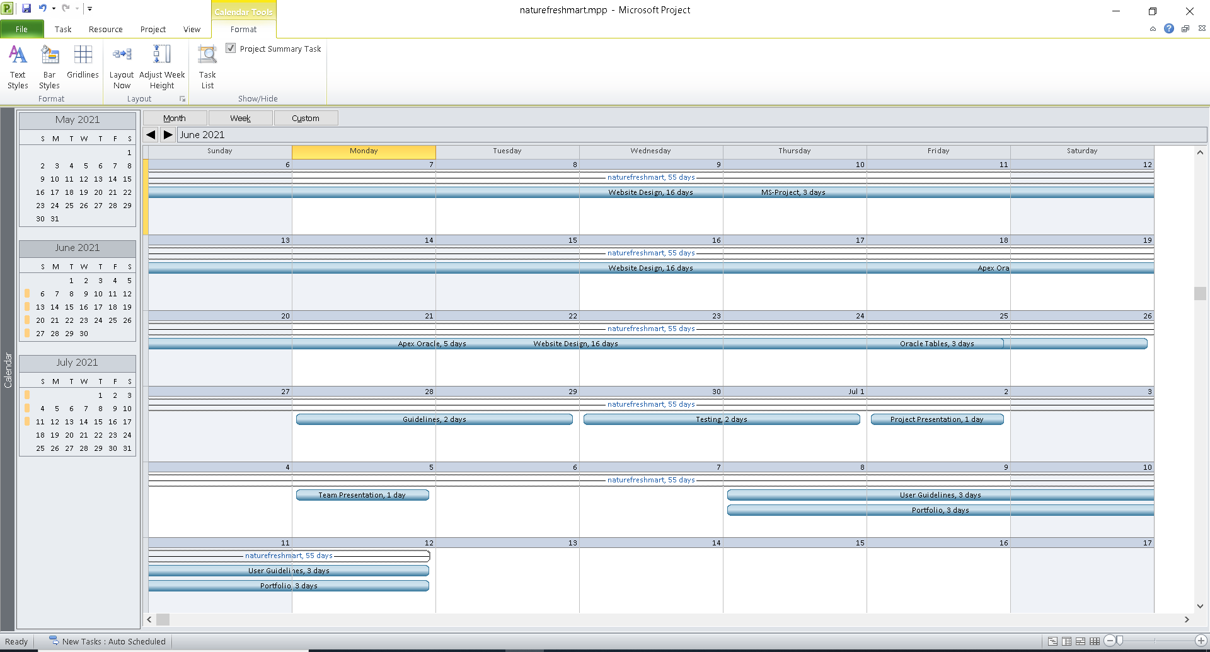

Resource Sheet

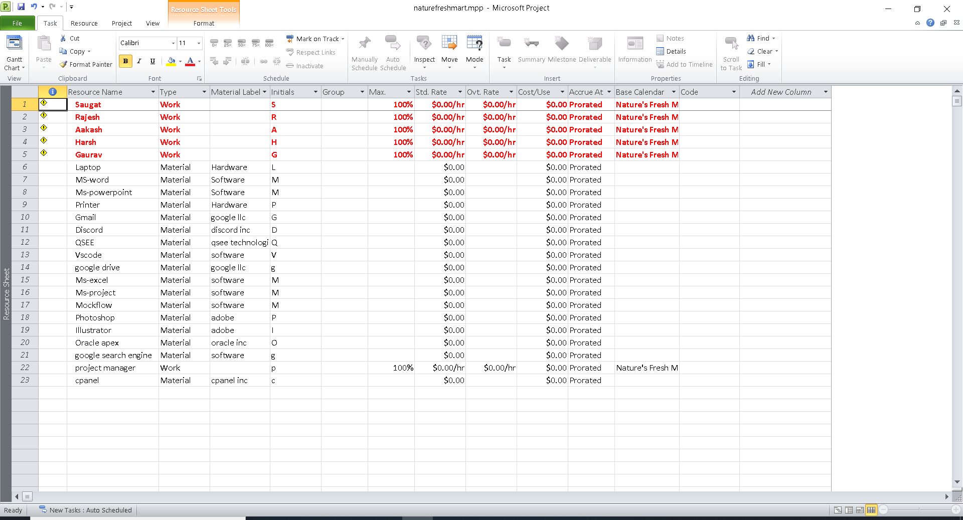

Change Working Time

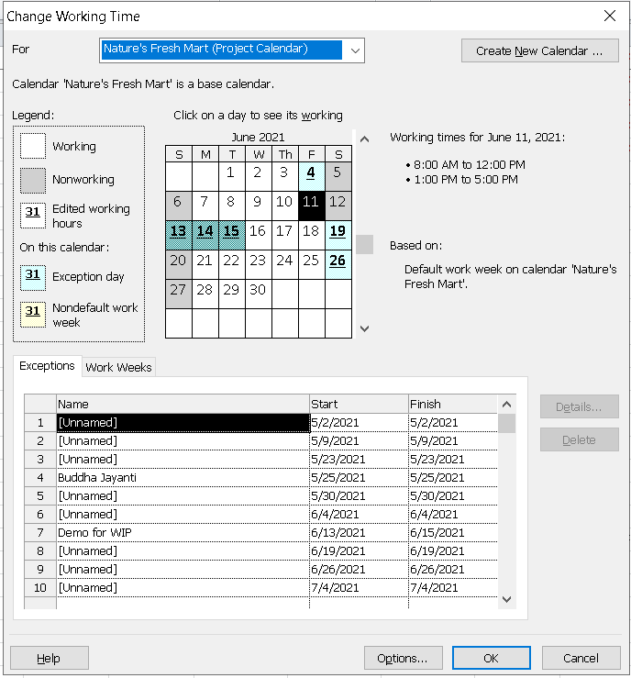

Task Sheet

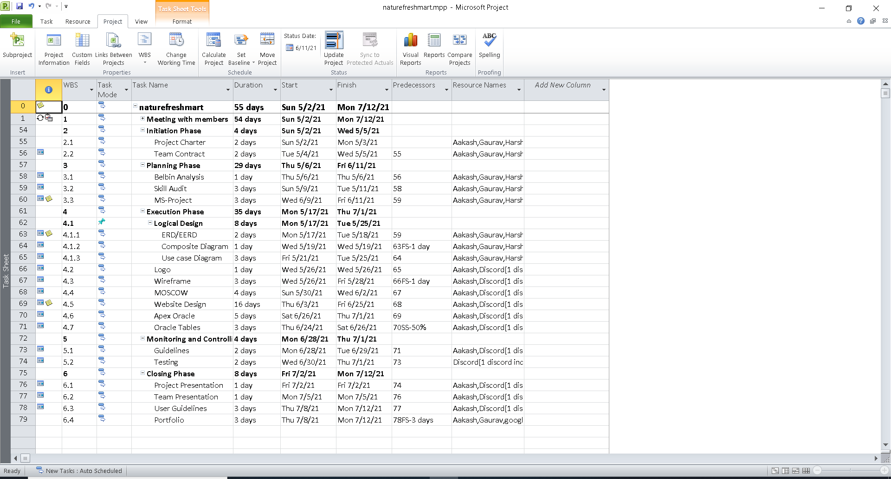

2.4 Communication Tool Used

Google Drive

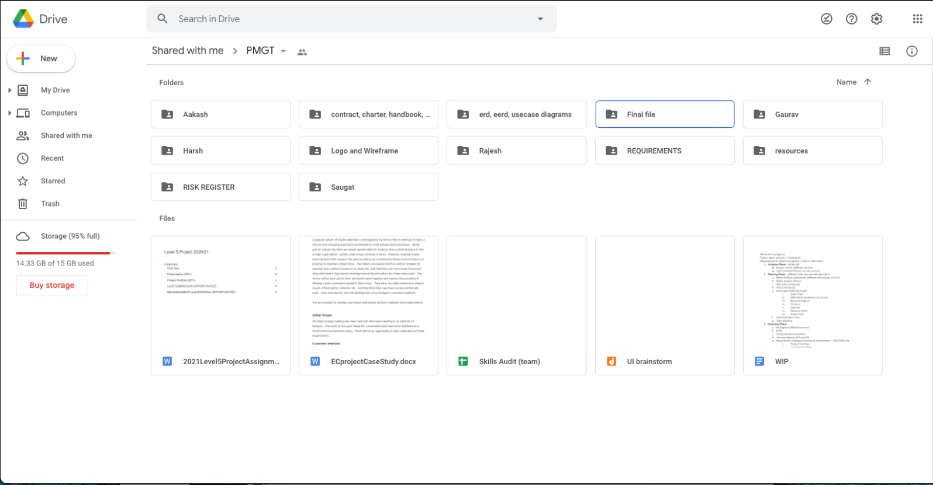

Discord

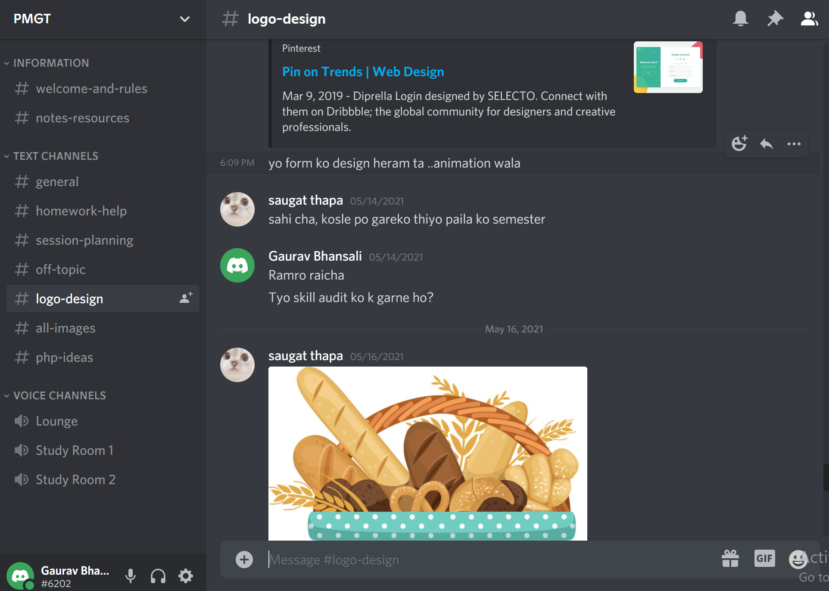

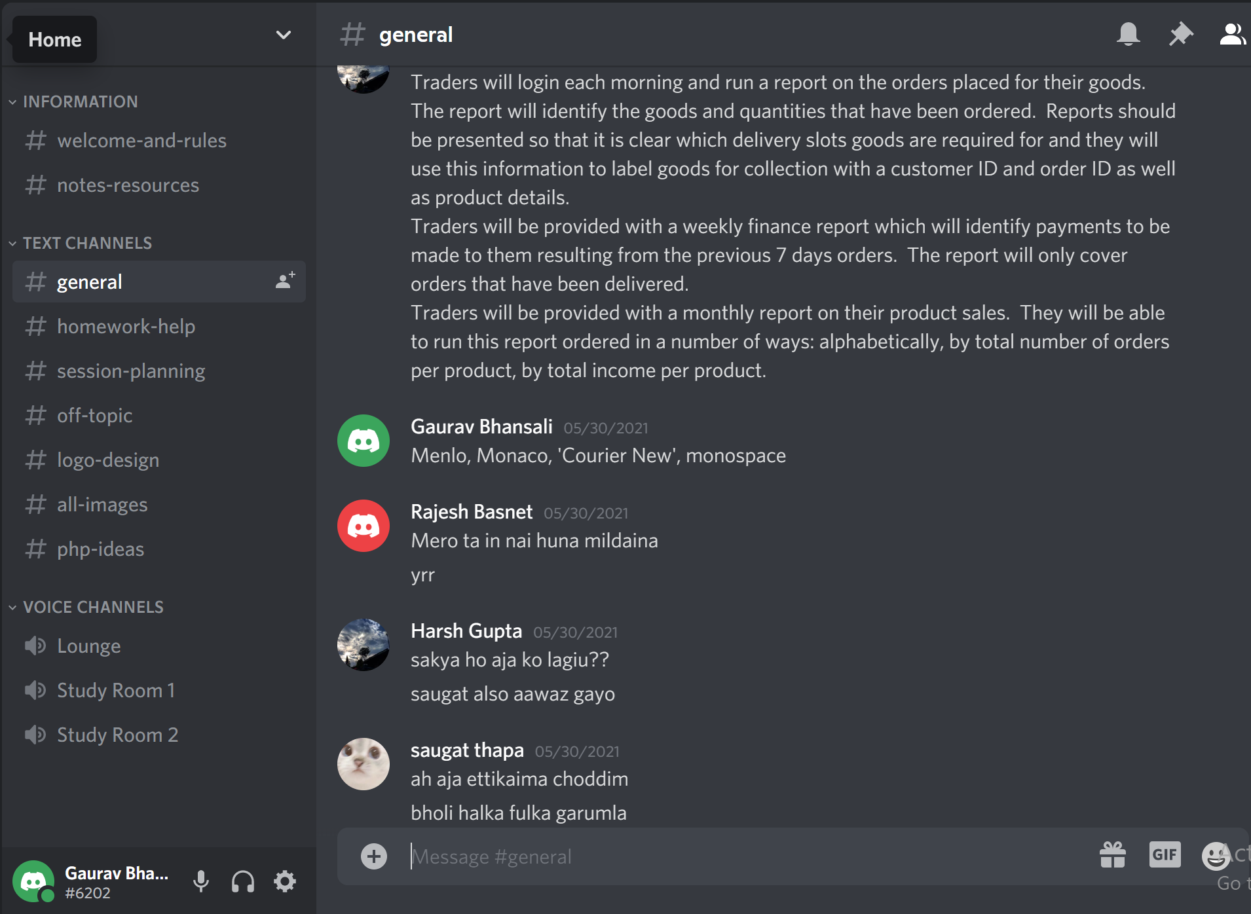

**3. Execution**

3.1 Extended Entity Relationship Diagram (EERD)



Entity Relationship Diagram(ERD)



Composite Extended Entity Relationship Diagram (EERD)





Logical Design

**TRADER** (TRADER_ID(PK))

**SHOP** (SHOP_ID(PK), SHOP_NAME, *TRADER_ID(FK)*)

**CUSTOMER** (CUSTOMER_ID(PK))

**ORDERS** (ORDER_ID(PK), TOTAL_SUM, DELIVERY_DATE, *CUSTOMER_ID(FK), COLLECTION_SLOT_ID(FK)*)

**PRODUCT** (PRODUCT_ID(PK), NAME, QUANTITY_IN_STOCK, AVAILABILITY, MIN_ORDER, ITEM_PRICE, MAX_ORDER, ALLERGY_INFO, DISCOUNT, MORE_INFO, PRODUCT_IMAGE, *OFFER_ID(FK), SHOP_ID(FK)*)

**REVIEW**(REVIEW_ID(PK), RATING, COMMENT*, PRODUCT_ID(FK), USER_ID(FK))*

**PRODUCT** (PRODUCT_ID(PK), NAME, QUANTITY_IN_STOCK, AVAILABILITY, MIN_ORDER, ITEM_PRICE, MAX_ORDER, ALLERGY_INFO, DISCOUNT, MORE_INFO, PRODUCT_IMAGE, *OFFER_ID(FK), SHOP_ID(FK)*)

**ORDER_PRODUCTS** (*ORDER_ID (FK),* *PRODUCT_ID(FK),* QUANTITY)

**COLLECTION_SLOT** (COLLECTION_SLOT_ID(PK), COLLECTION_TIME, COLLECTION_DAY)

**PAYMENT** (TRANSACTION_ID(PK*), ORDER_ID(FK), USER_ID(FK)*)

**OFFER** (OFFER_ID(PK), PERCENTAGE, DESCRIPTION)

**REVIEW** (REVIEW_ID(PK), RATING, COMMENT, *PRODUCT_ID(FK), USER_ID(FK))*

**USERS** (USER_ID(PK), FIRST_NAME, LAST_NAME, ADDRESS, EMAIL, PASSWORD)

**PAYMENT** (TRANSACTION_ID(PK), *ORDER_ID(FK), USER_ID(FK)*)

3.2 Use Case Model

Overview Use Case Diagram



Customer Use Case Diagram

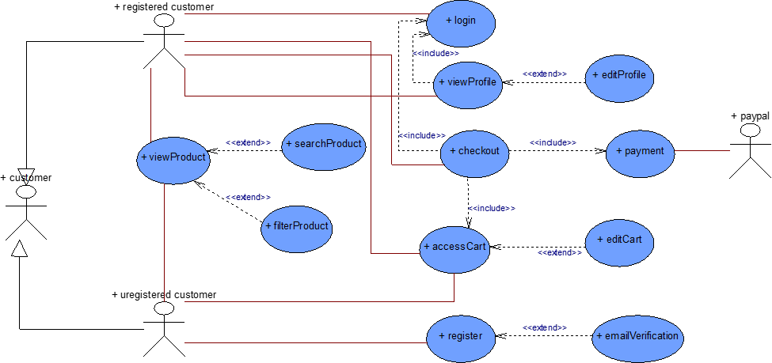

Trader Use Case Diagram

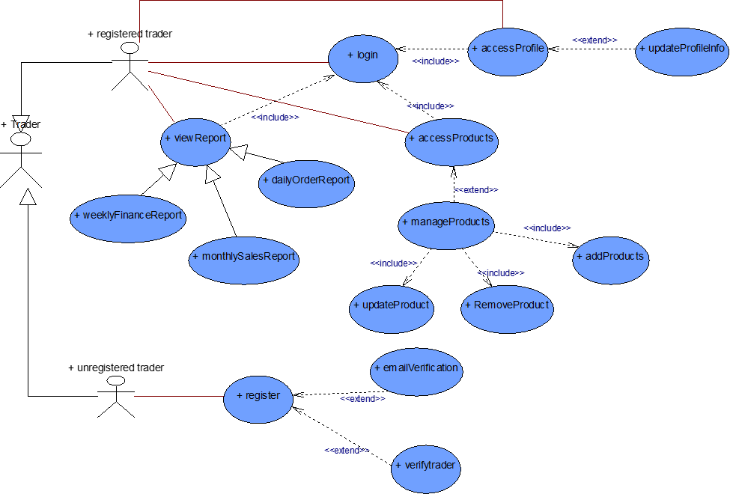

Admin Use Case Diagram

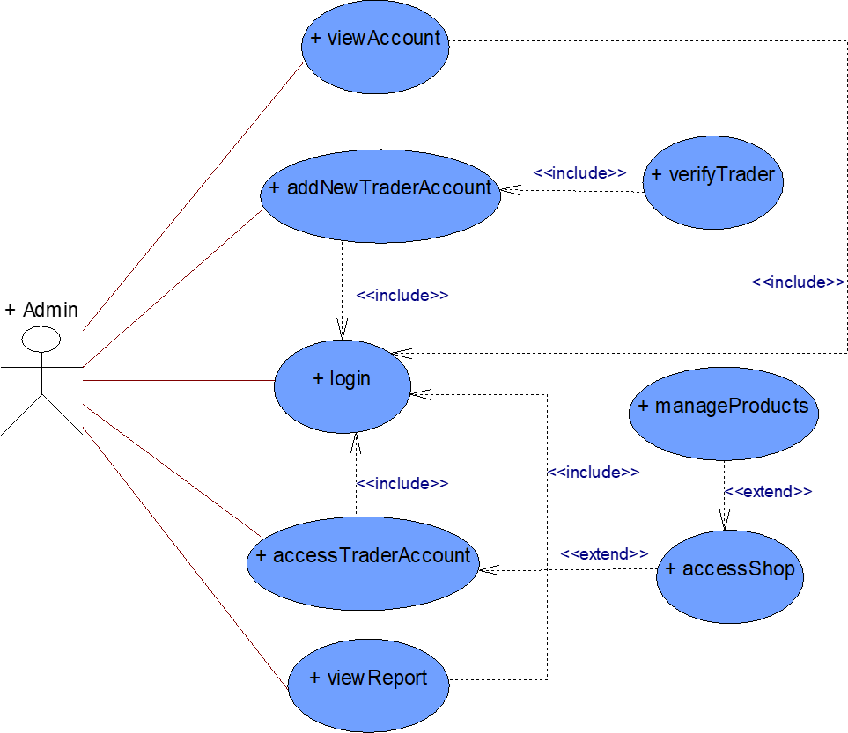

3.3 Requirement Catalogue

Functional Requirements:

1. **PRODUCT**

|  |  |  |
| --- | --- | --- |
| **REQUIREMENT ID** | **DESCRIPTION** | **MOSCOW RULE** |
| **A1** | **Product description** |  |
| **A1-01** | Products will have a unique id. | **M** |
| **A1-02** | Products will have a name and price. | **M** |
| **A1-03** | Products will be associated with at least one trader. | **M** |
| **A1-04** | Products will have max and min order capacity , stock availability  and description. | **M** |
| **A1-05** | Products will have allergy information if needed. | **S** |
| **A1-06** | Products will have an enabled or disabled status. | **S** |
| **A1-07** | Products will have delivery-storage information. | **C** |

1. **CUSTOMER  INTERFACE**

|  |  |  |
| --- | --- | --- |
| **REQUIREMENT ID** | **DESCRIPTION** | **MOSCOW RULE** |
| **B1** | **An Interface that allows the customers to view and buy products** |  |
| **B1-01** | Customers will be able to sort products according to name and price. | **M** |
| **B1-02** | Customers will be able to search for products inside each shop. | **M** |
| **B1-03** | Customers will be able to view information about products like price, stock and so on. | **M** |
| **B1-04** | Customers will be able to rate and leave reviews on products. | **S** |
| **B1-05** | Customers will be able to search for products directly from the home page. | **C** |
| **B2** | **Cart interface for customers** |  |
| **B2-01** | Customers will be able to add products to a single cart from different shops. | **M** |
| **B2-02** | Customers will be able to view the total price. | **M** |
| **B2-03** | Customers will be able to delete items from the cart individually or all at once. | **S** |
| **B2-04** | Customers will be able to add more of the same products from the cart itself. | **C** |
| **B3** | **Product payment and collection** |  |
| **B3-01** | Customers will be able to make online payments via PayPal. | **M** |
| **B3-02** | Customers will be able to login to their account. | **M** |
| **B3-03** | Customers will be able to view their orders. | **M** |
| **B3-04** | Customers will be able to choose collection slots. | **M** |
| **B3-05** | Customers can add products to favourites if they are logged in. | **C** |
| **B3-06** | Customers can remove items from favourites. | **C** |
| **B3-07** | Customers will be able to cancel orders after they have been placed. | **C** |
| **B3-08** | Customers will be able to return products that are not satisfied with the quality. | **C** |

1. **TRADER  INTERFACE**

|  |  |  |
| --- | --- | --- |
| **REQUIREMENT ID** | **DESCRIPTION** | **MOSCOW RULE** |
| **C1** | **An Interface that allows the traders to manage their products** |  |
| **C1-01** | All products of every trader will have their unique trader ID. | **M** |
| **C1-02** | All traders will have at least one shop each. | **M** |
| **C1-03** | Traders will be able to manage their personal information excluding passwords. | **M** |
| **C1-04** | Traders will be able to update, insert and delete products. | **M** |
| **C1-05** | Each trader should have at least one product. | **M** |
| **C1-06** | Traders should be able to login to their account. | **M** |
| **C1-07** | Traders will be able to change their password by  and type of product by themselves without the help of admin. | **C** |
| **C2** | **Payment of the trader** |  |
| **C2-01** | Each trader will receive a receipt for each item sold which can be accessed using their accounts. | **M** |
| **C2-02** | Each trader will receive a single receipt for all items sold that day which can be accessed using their accounts. | **C** |
| **C3** | **Daily, weekly and Monthly Reports** |  |
| **C3-01** | All reports will be available to the traders after they’ve logged in. | **M** |
| **C3-02** | Daily reports will be available to the traders after they’ve logged in. | **M** |
| **C3-03** | Weekly financial reports will be available to the traders after they’ve logged in. | **M** |
| **C3-04** | Monthly sales reports will be available to the traders after they’ve logged in. | **M** |

1. **LOGIN AND REGISTRATION**

|  |  |  |
| --- | --- | --- |
| **REQUIREMENT ID** | **DESCRIPTION** | **MOSCOW RULE** |
| **D1** | **An Interface that allows customers to login or register** |  |
| **D1-01** | Customers will be able to login using username and password. | **M** |
| **D1-02** | New customers will be required to fill out a form which will minimally require name, email and password. | **M** |
| **D1-03** | Email verification links will be sent for customer verification. | **M** |
| **D1-04** | Server side validation for user login. | **S** |
| **D1-05** | Login option will be available on each page if the user is not logged in. | **S** |
| **D1-06** | Server side validation for incorrect login attempt. | **S** |
| **D2** | **An Interface that allows trader to login or register** |  |
| **D2-01** | New traders will be required to fill out a form that collects first name, last name, email, address, mobile number, password and terms and conditions checkbox. | **M** |
| **D2-02** | Email verification links will be sent for trader verification. | **M** |
| **D2-03** | Traders will be able to login to their account using username and password. | **M** |
| **D2-04** | Server side validation for trader login. | **S** |
| **D2-05** | Server side validation for incorrect login attempt. | **S** |
| **D2-06** | Apply appropriate strategies to ward off potential security threats. | **C** |

1. **MANAGEMENT INTERFACE**

|  |  |  |
| --- | --- | --- |
| **REQUIREMENT ID** | **DESCRIPTION** | **MOSCOW RULE** |
| **E1** | **An Interface that allows admin to login** |  |
| **E1-01** | Admins will login using their username and password. | **M** |
| **E1-02** | After logging in, admin can access any of the trader accounts. | **S** |
| **E1-03** | Admin can disable any trader’s products | **S** |
| **E1-04** | Admin can deactivate a trader's account. | **C** |
| **E1-05** | Admin can delete a trader's products. | **C** |
| **E2** | **Dashboard and Report** |  |
| **E2-01** | Admin users can access the admin home page and dashboard. | **M** |
| **E2-02** | Admin has access to all reports of the traders. | **M** |

Non-functional requirement

|  |  |  |
| --- | --- | --- |
| **REQUIREMENT ID** | **DESCRIPTION** | **MOSCOW RULE** |
| **NF1** | **An Interface that allows admin to login** |  |
| **NF-01** | The website will be scalable so future development in the website is feasible. | **M** |
| **NF1-02** | The website load time won't exceed 5 seconds. | **S** |
| **NF1-03** | Server side validation for all users login. | **M** |
| **NF1-04** | Proper documentation of code for code maintainability. | **M** |
| **NF1-05** | High level of security for online payment transactions. | **S** |
| **NF1-06** | The traders will be notified no later than 12 hours after registration. | **S** |
| **NF1-07** | The customer can access the cart from any shop page or product page directly. | **M** |

3.4 Logo Design



3.5 Wireframe

**Home Page**

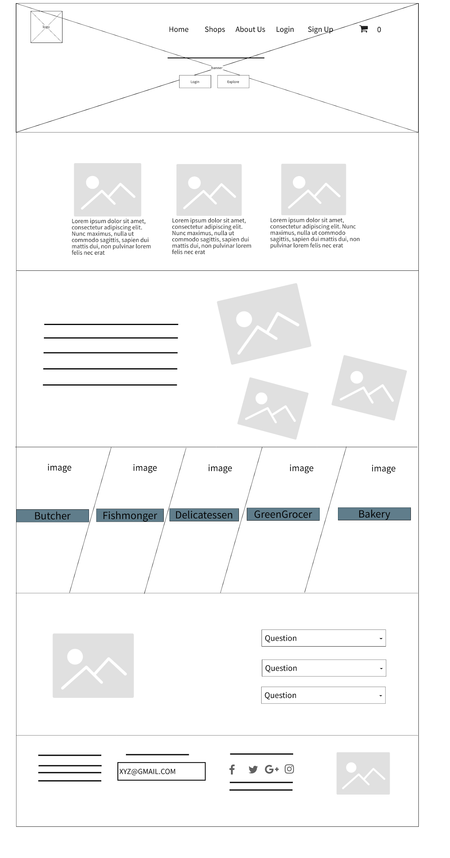

**Shop Page**

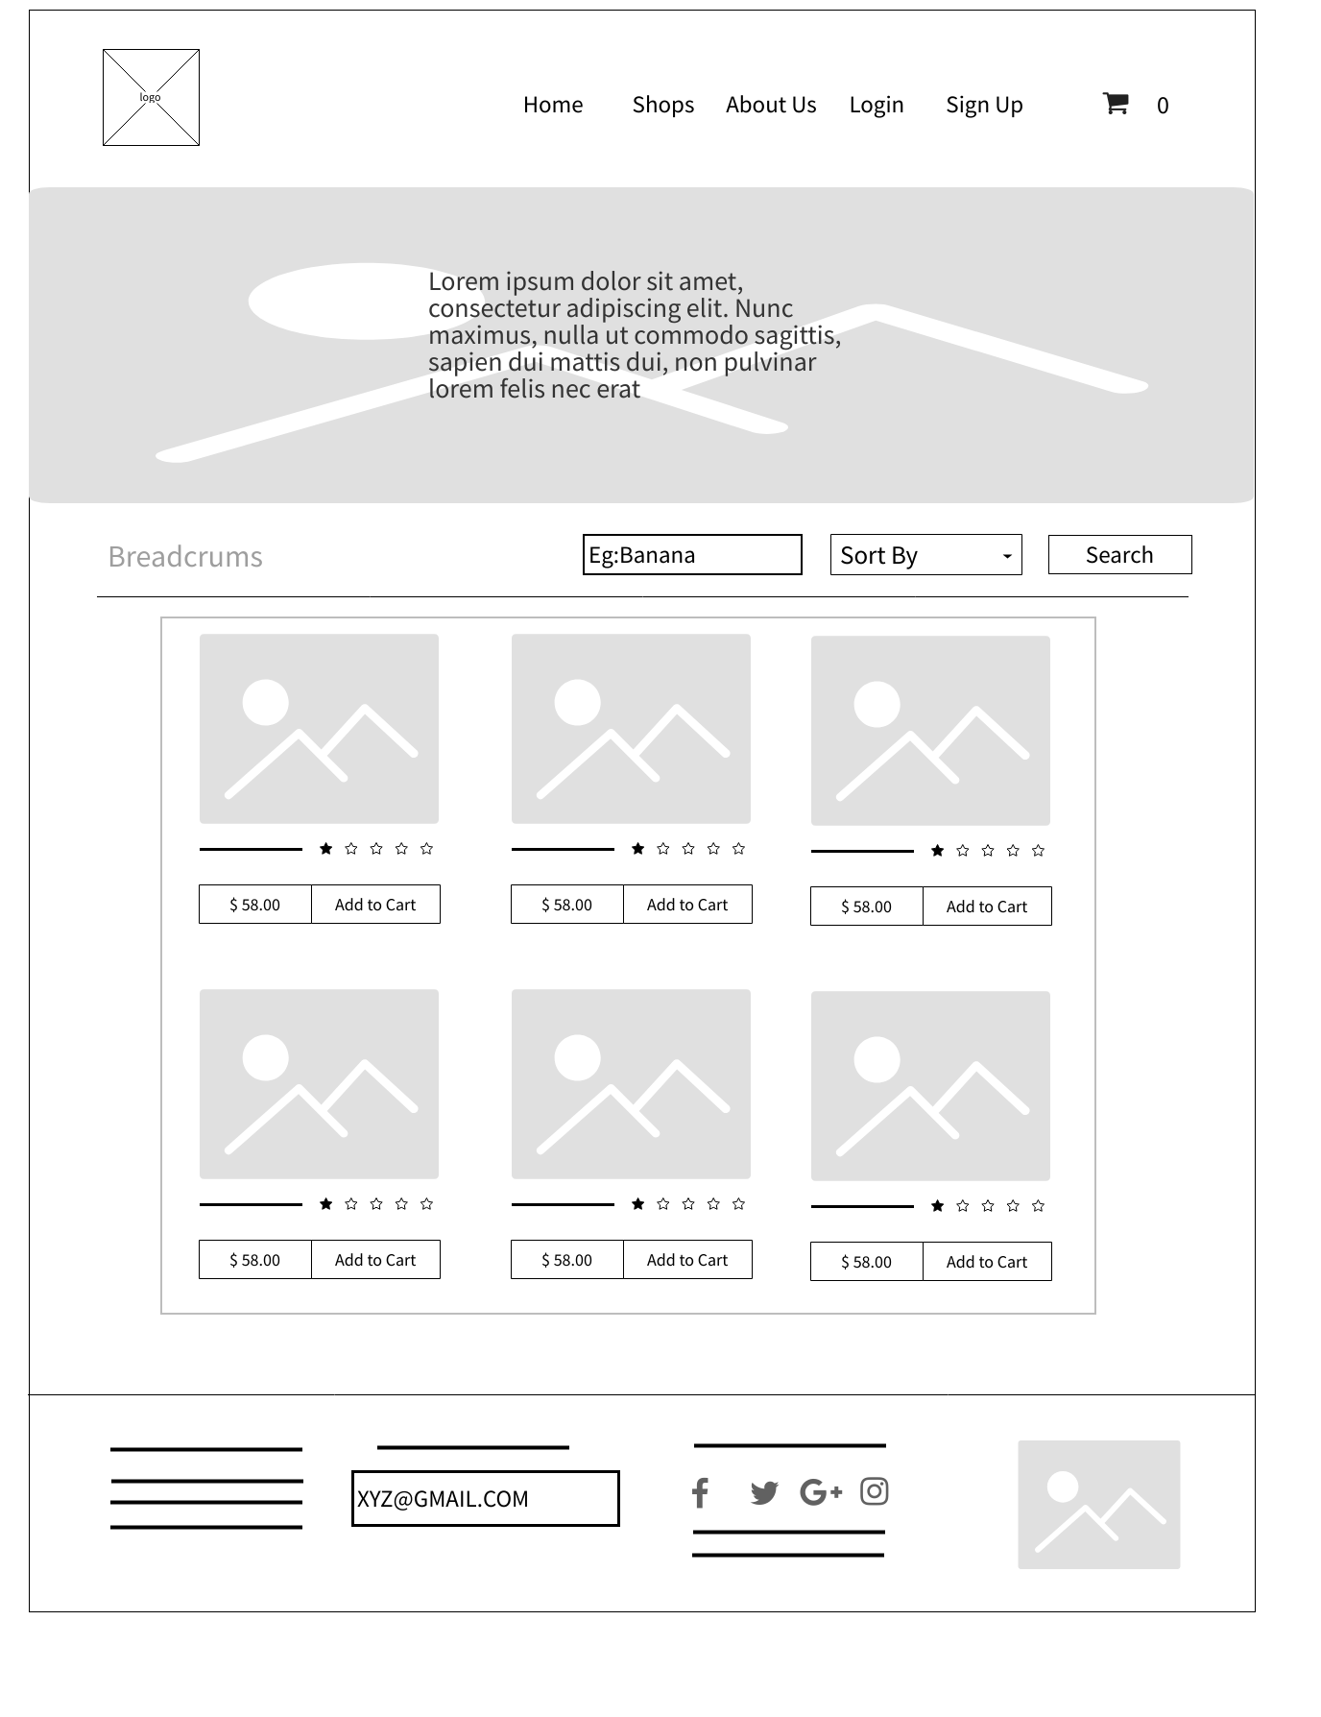

**Individual Product Page**

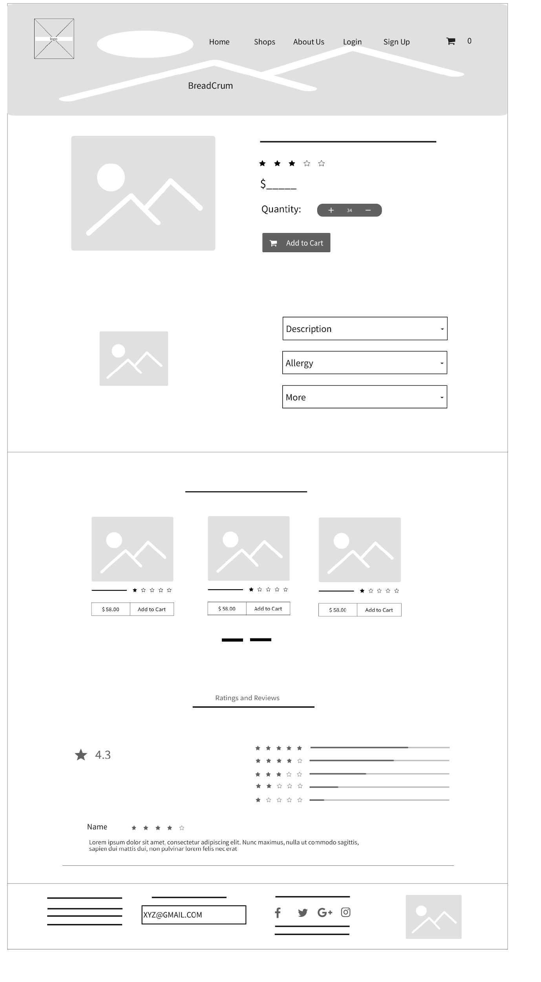

**Sign Up/Register Customer**

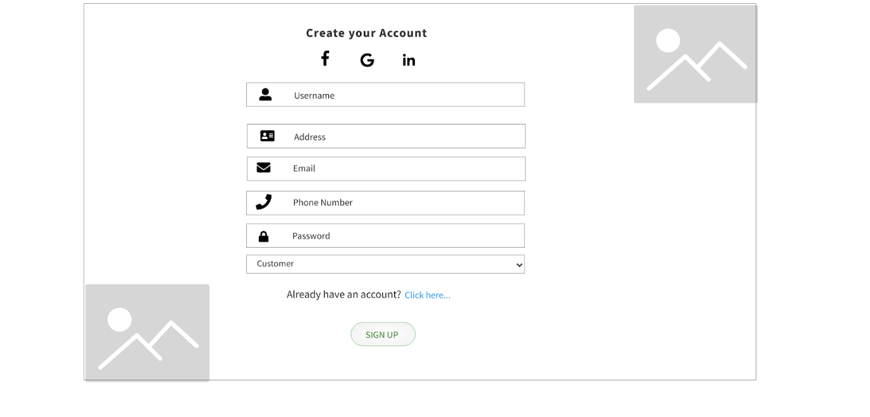

**Sign Up/Register Trader**

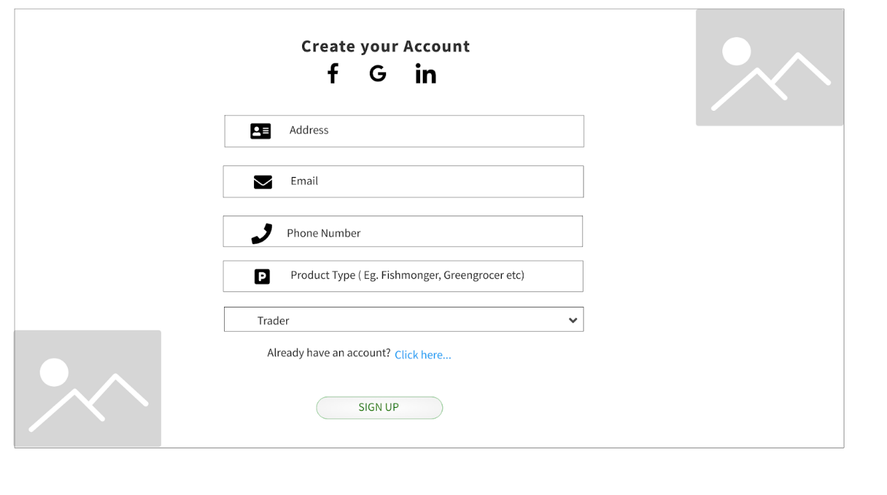

**Sign in Customer/Trader/Admin**

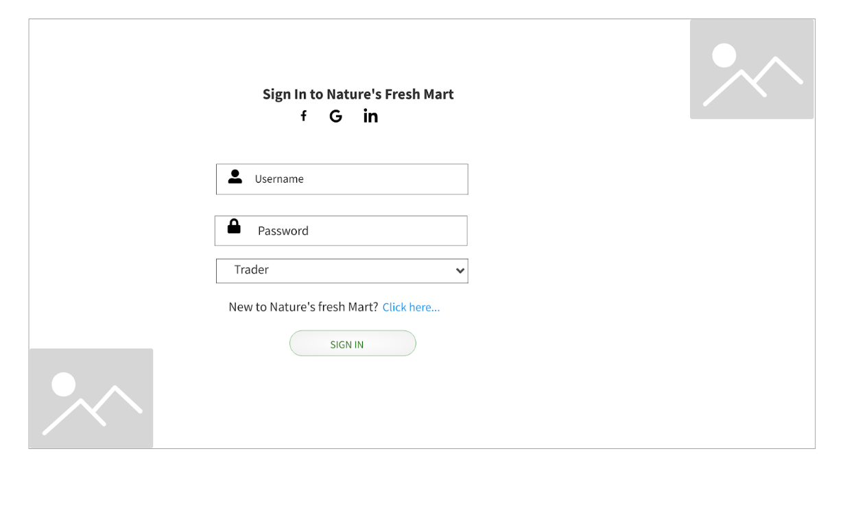

**Customer Profile Setting(php)**

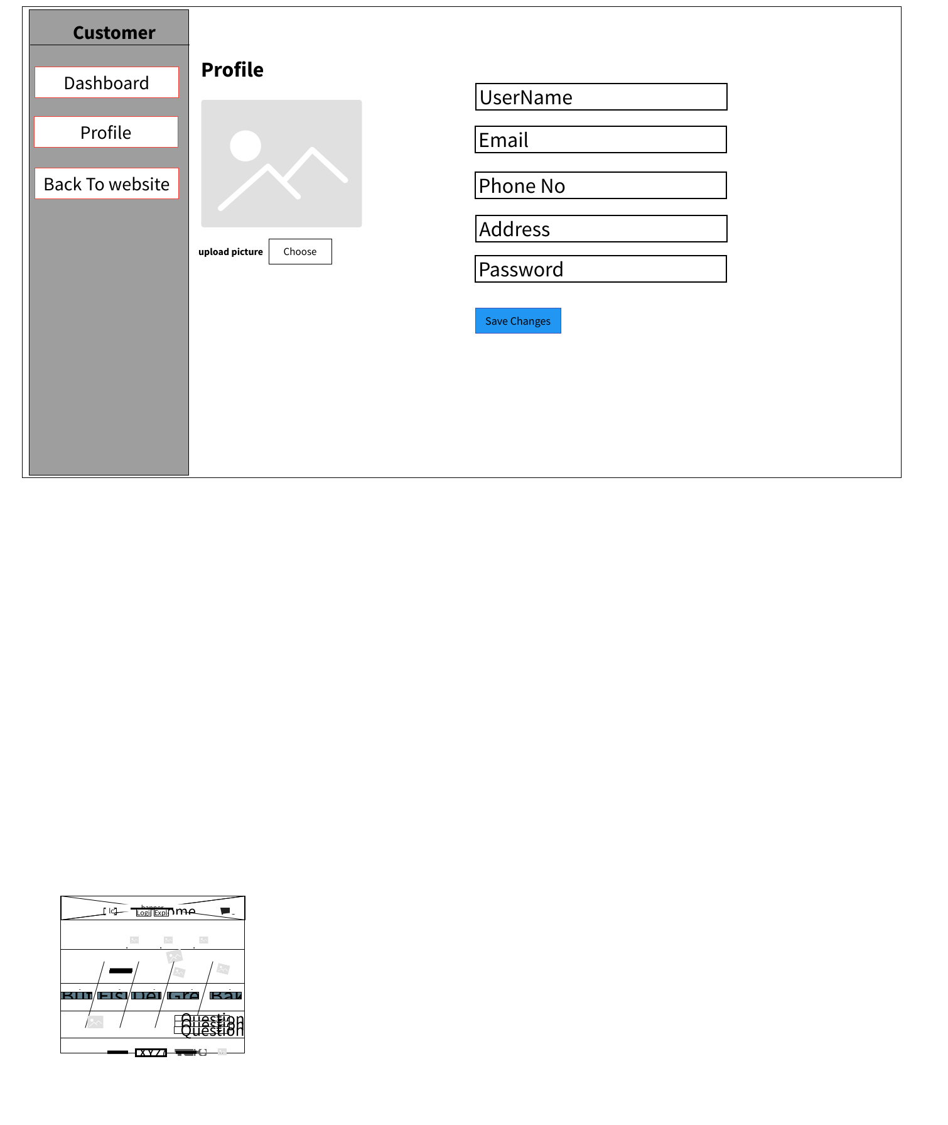

**Trader Interface(php)**

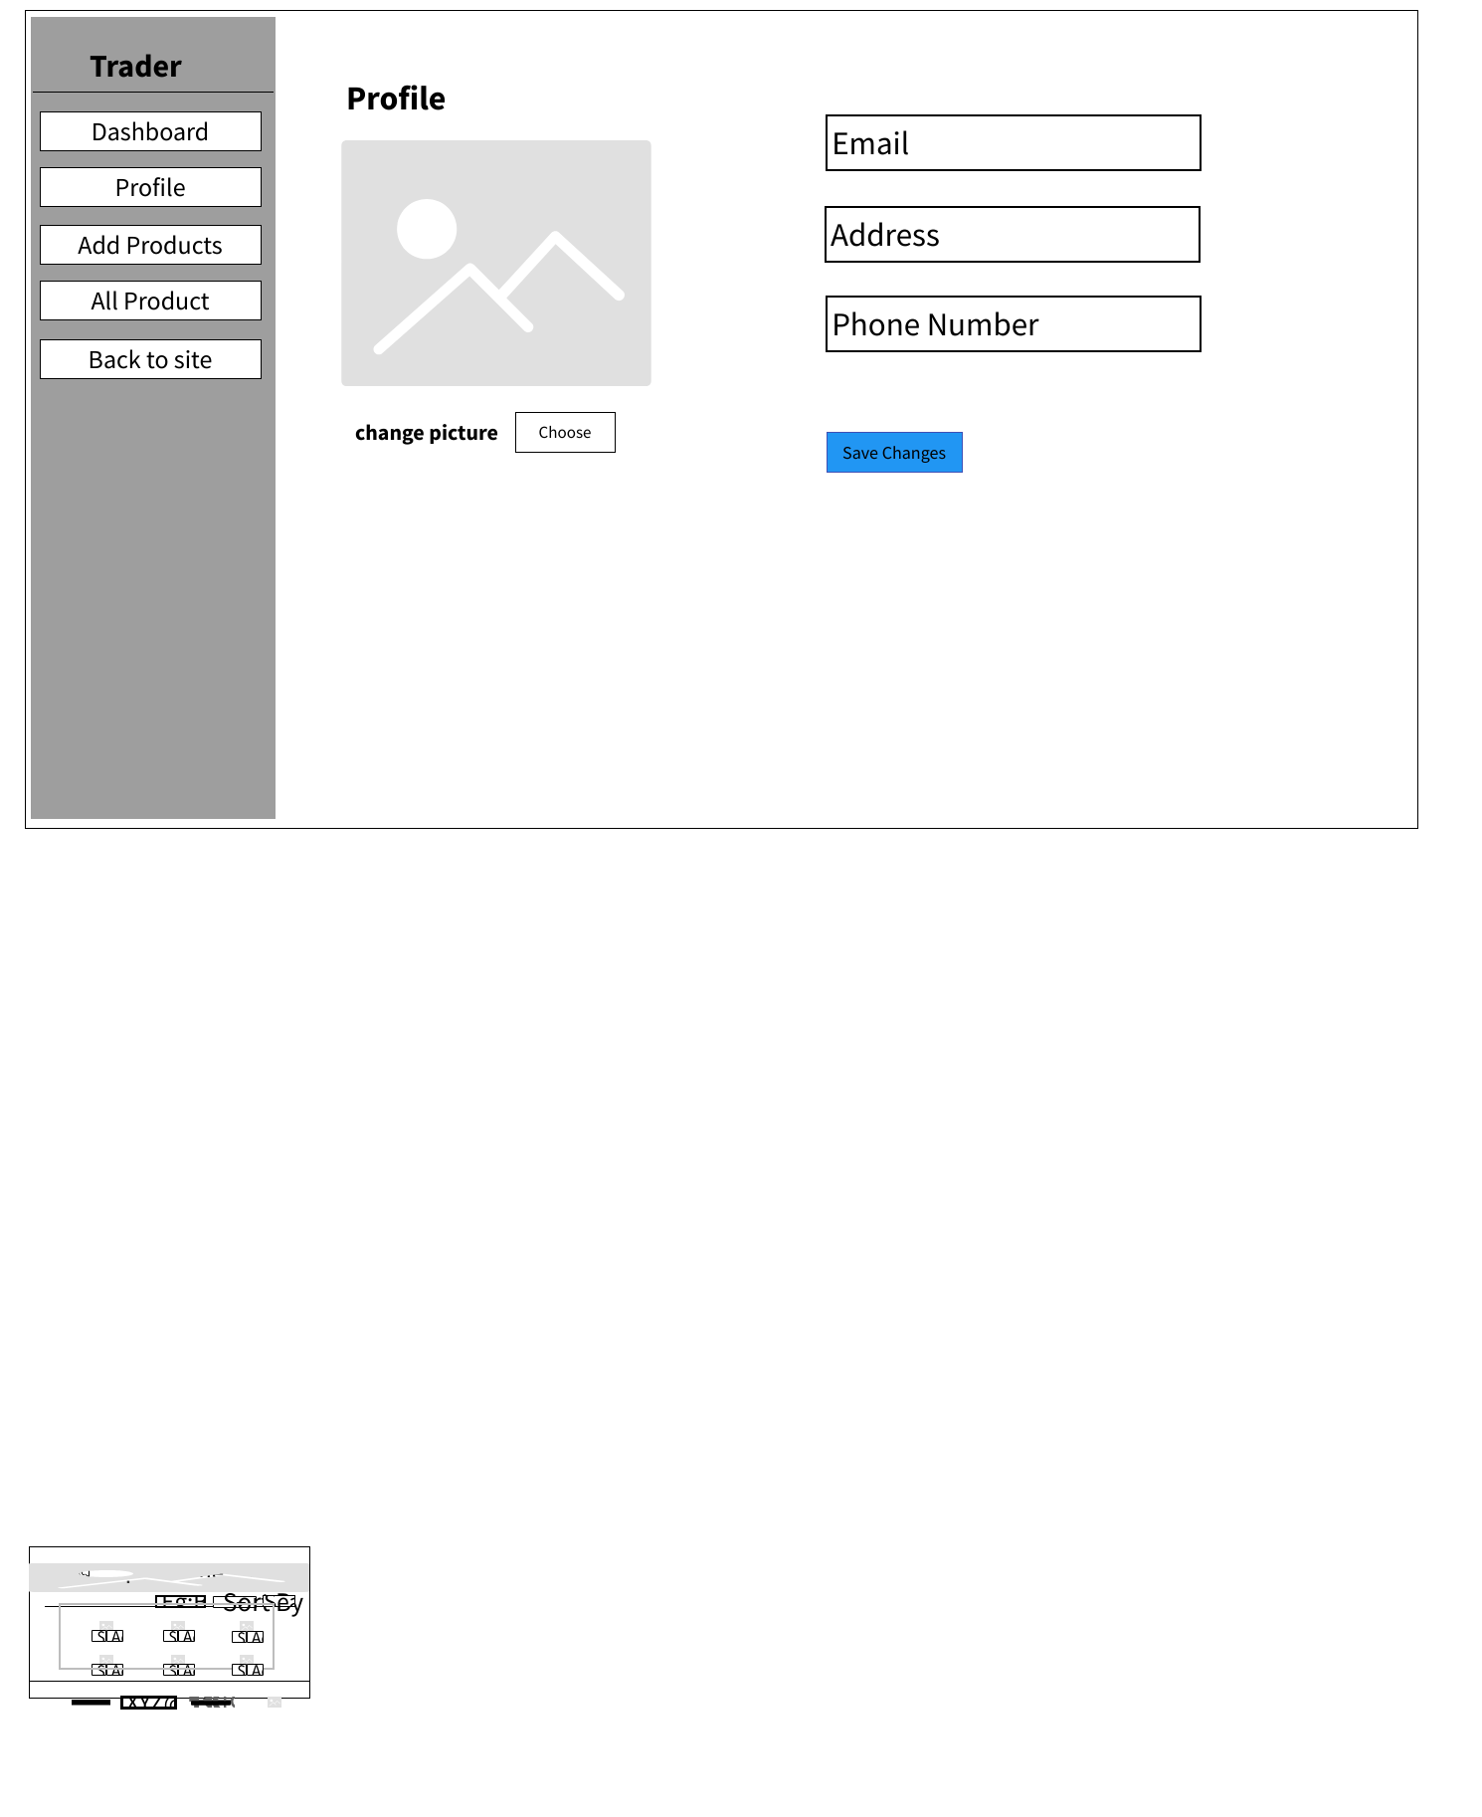

**Admin Interface(php)**

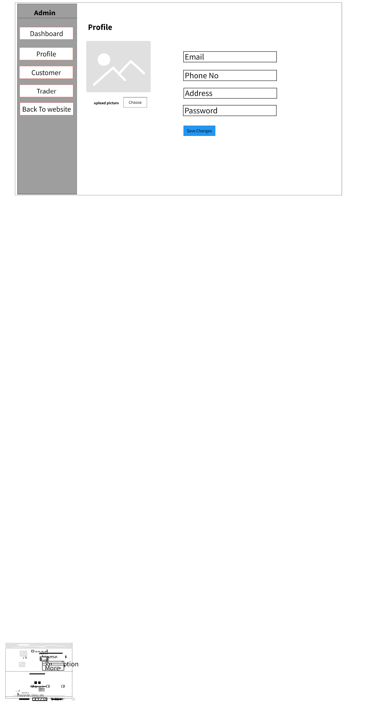

**Invoice**

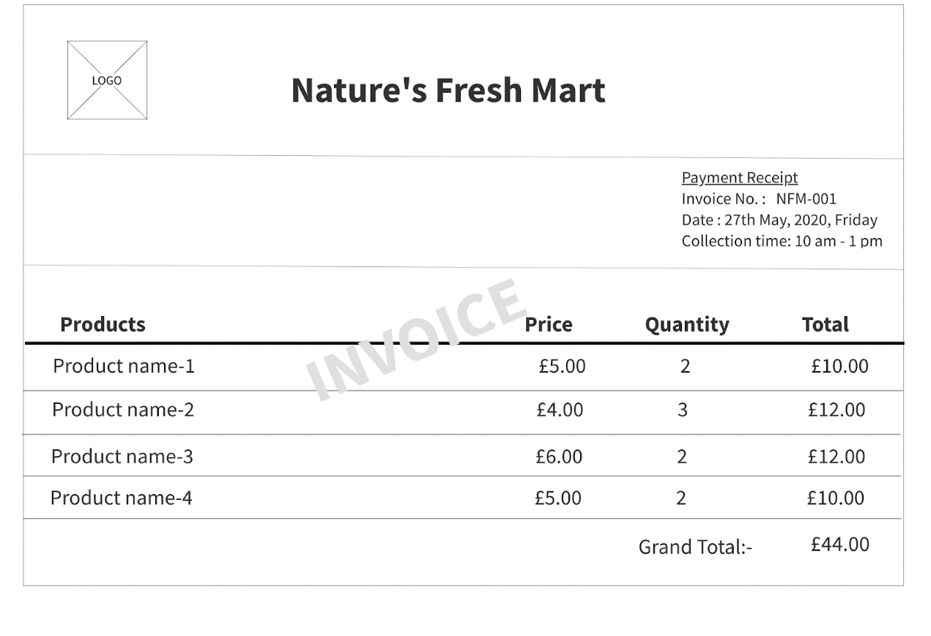

**CART**

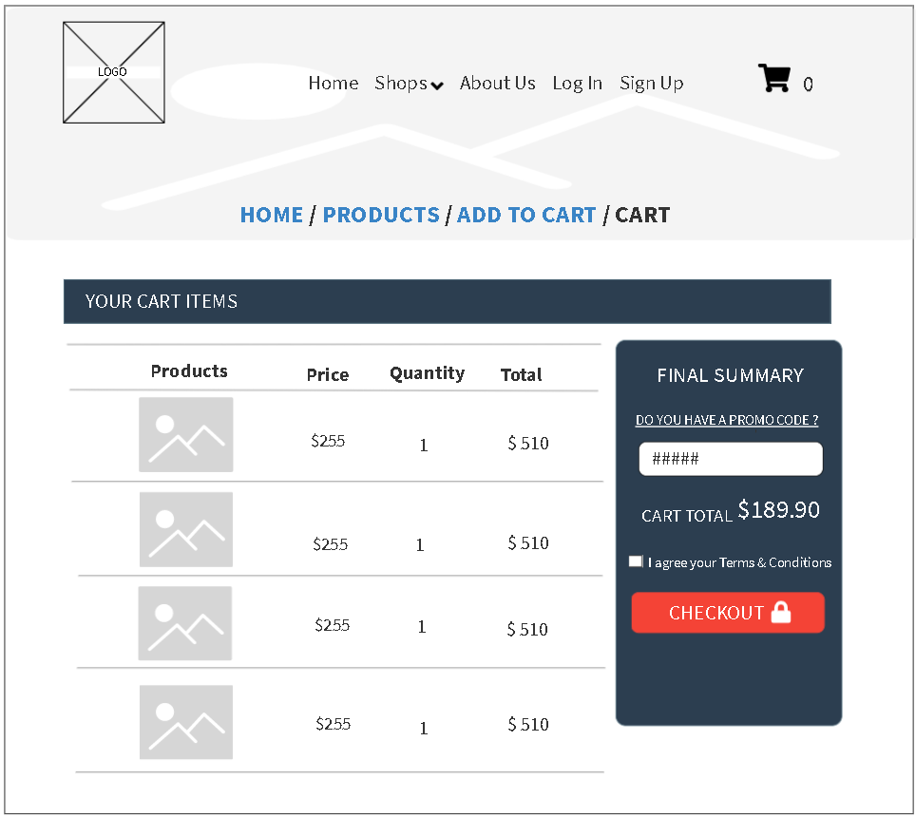

**Add Product**

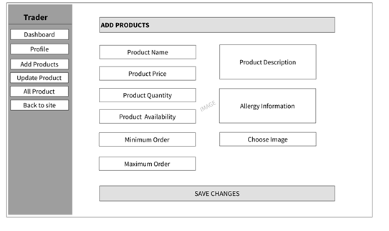

**Update Product**

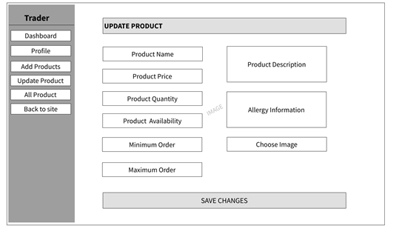

**About Us**

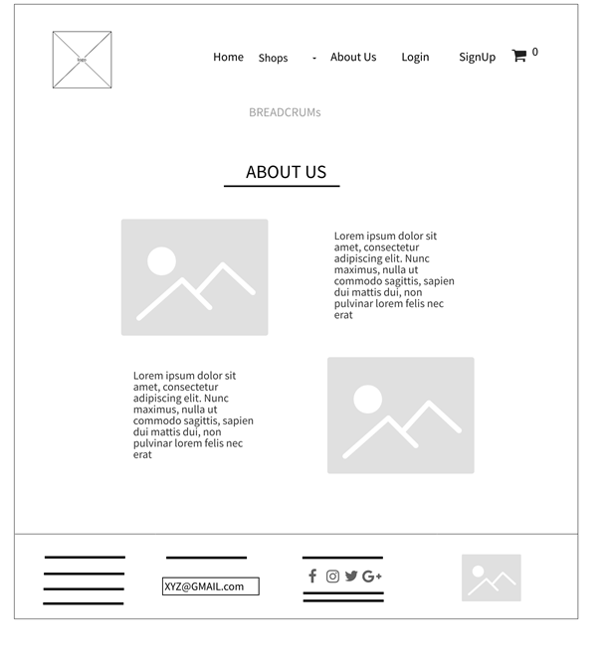

**Oracle apex**

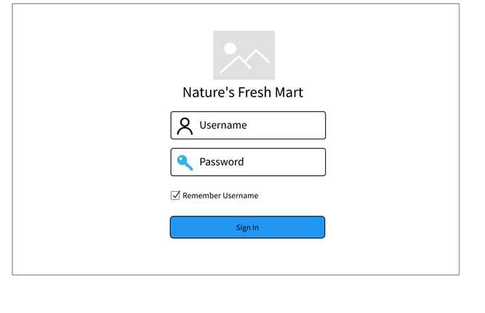

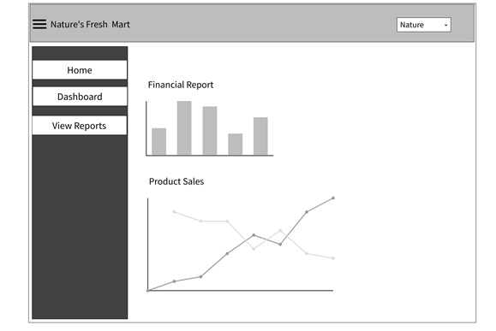

* 1. Product Development

Homepage:

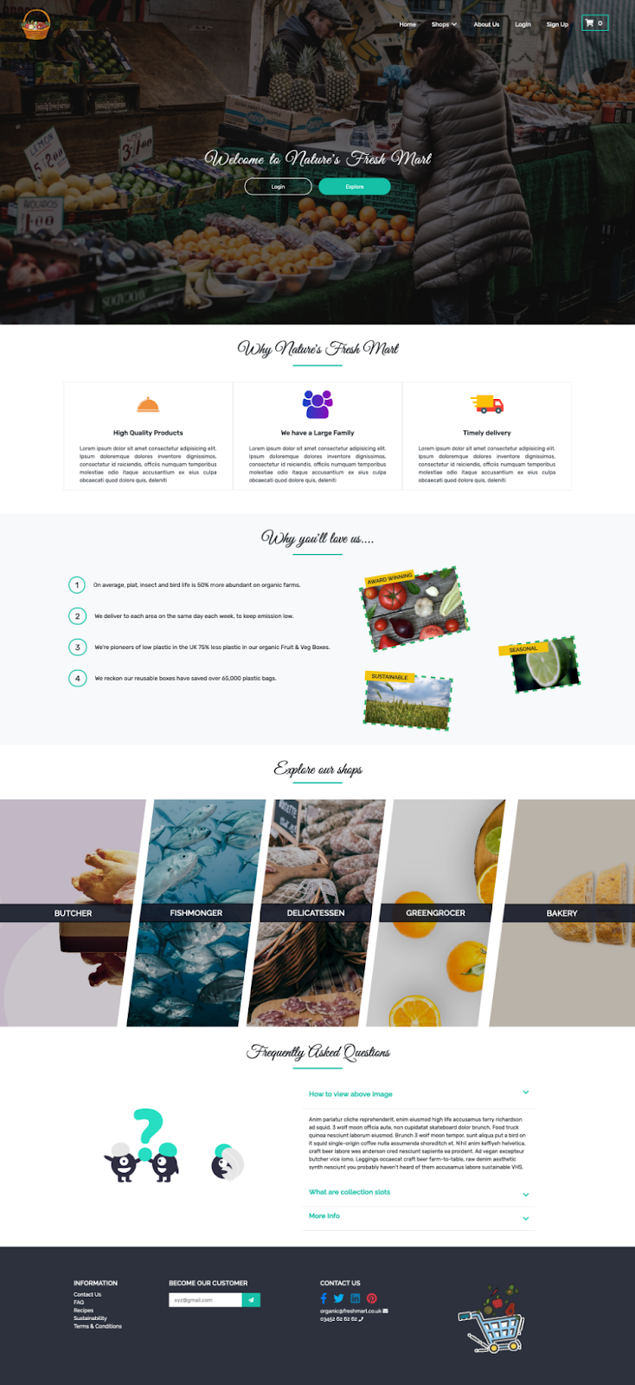

Product Page:

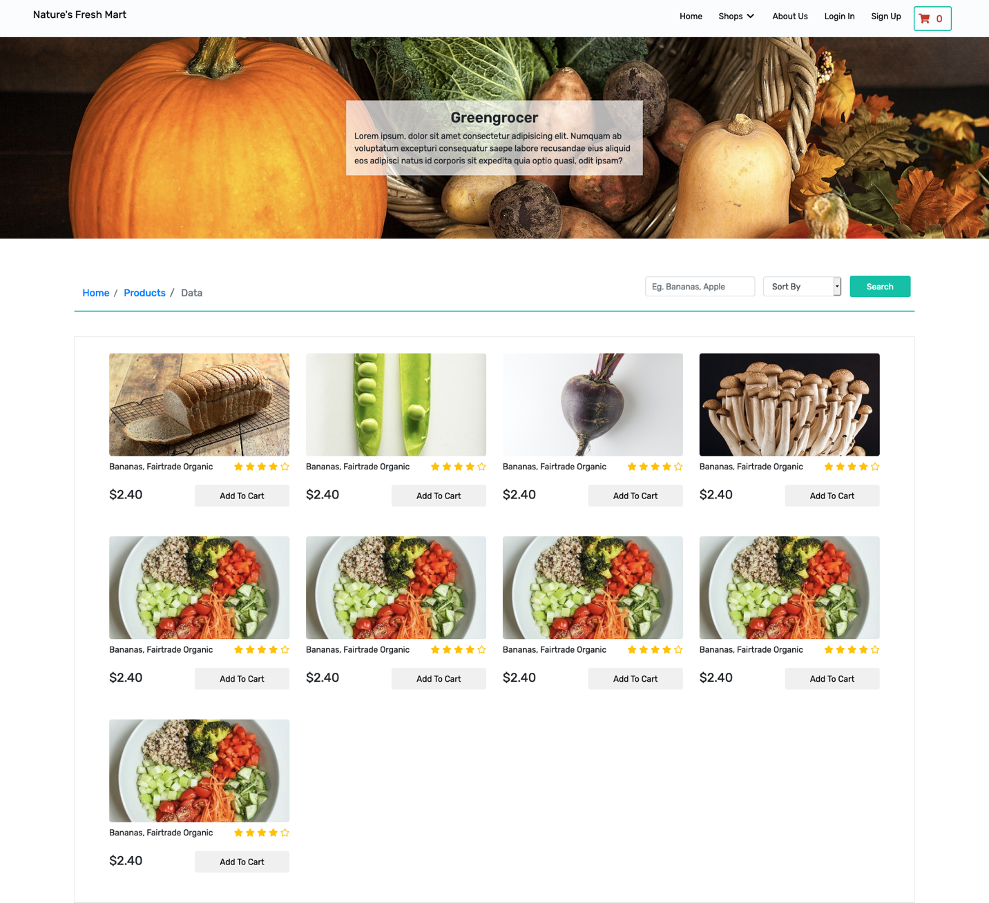

Sign in:

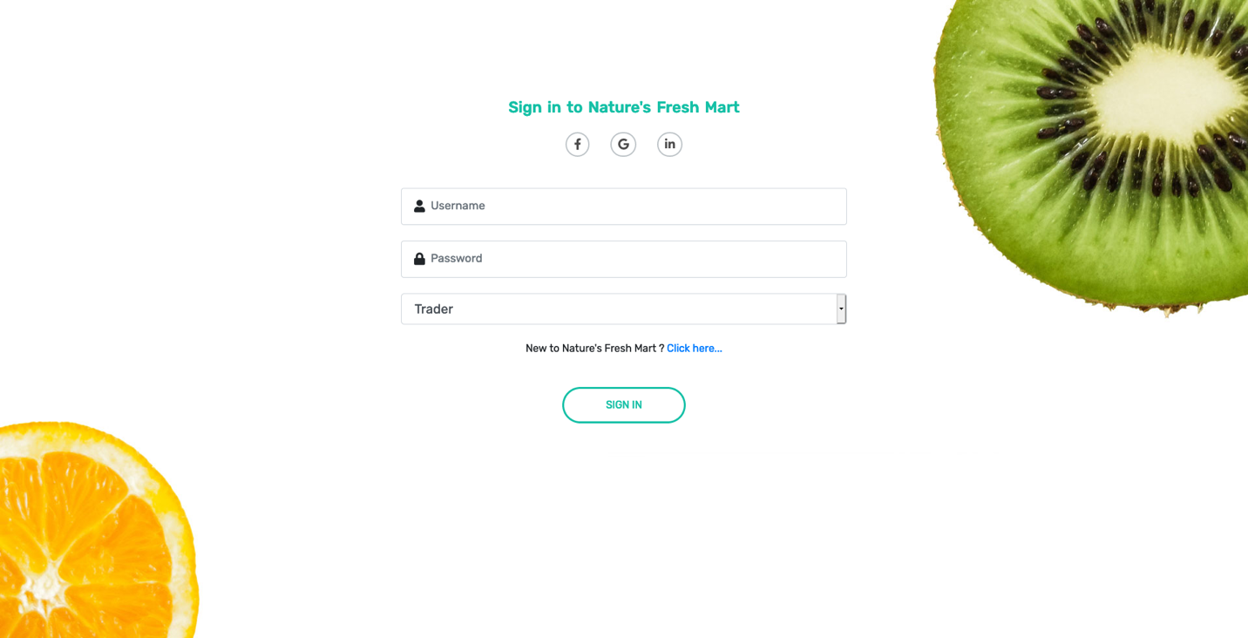

THANK YOU